Foundry Healthcare Model

Digital Standard Operating Procedure

RAG Rating of Patients

The key to the RAG rating of patients is that it is a clinician-lead decision made decision based on the level of continuity that you feel that patient needs. This is based on the template that pops up at the end of each consultation and asks the clinician to review their current categorisation and whether this is currently correct. When introducing this system for the first time there are two options:
- Introduce the pop up and the end of the consultation and then run this system for 3-6 months. At the end of this time then code everyone who does not have any RAG code as Green. This might mean that some Amber patients who have not been seen in 3-6 months are mis-coded as Green but in time they will be seen and the RAG categorisation will improve.
- Choose a particular search e.g. number of Long Term Conditions, Frailty codes, Electronic Frailty Index or combination of searches and set the RAG categories based on particular criteria within these searches. This will not be as accurate as the clinician-led pop up at the end of the consultation but once you have done this then you can set up the pop-up and over 3-12 months the RAG categorisation will get more accurate.

Technical Guide

Systmone

The building blocks of the RAG rating system are:

RAG Read codes:

 | Code Description | SNOMED | CTV3 Code
Green | General health good | 135815002 | XalMt
Amber | Chronic long term disease management required | 416239002 | XaKdU
Red | Chronic long term disease management required: complex needs | 416357003 | XaKdV

Clinical Template:

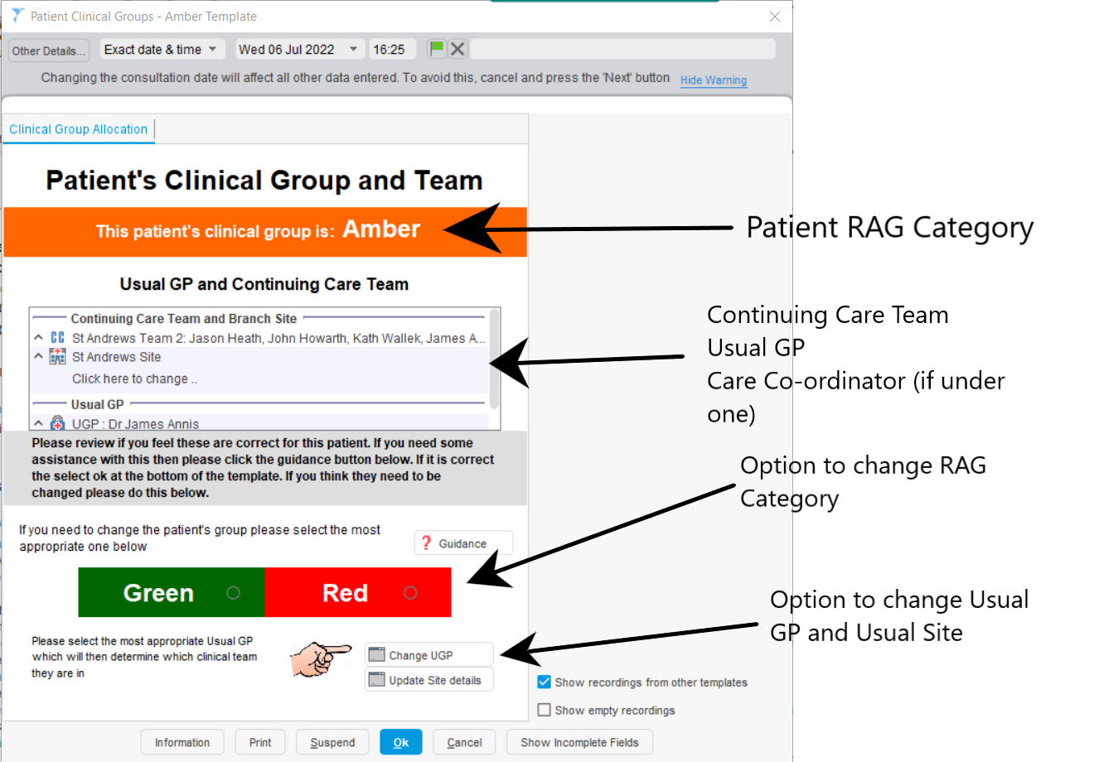
There is one version of this template for each of the RAG Categories

Clinical Reports

The clinical reports for each RAG group are setup to search for one of the RAG read codes without a more recent addition of one of the other two RAG read codes:
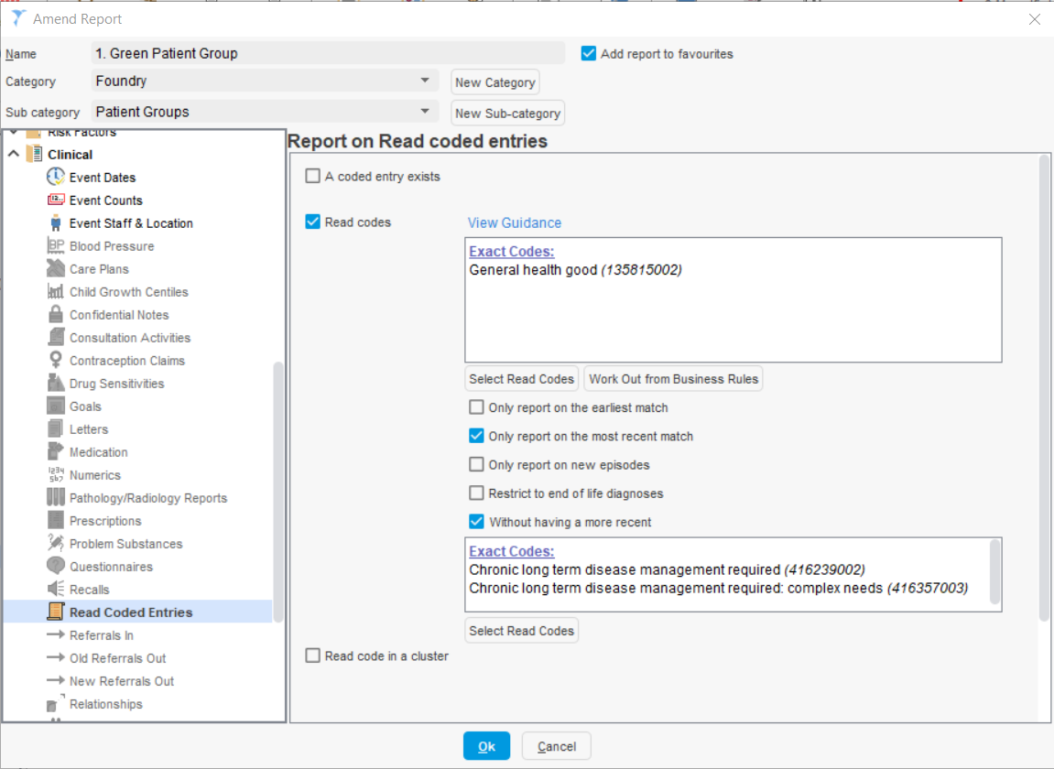

Protocol

The template pops up at the end of a consultation based on a protocol within Systmone that searches for which patient the group the patient belongs to in the clinical reports above and then launch the template relevant for that clinical group.
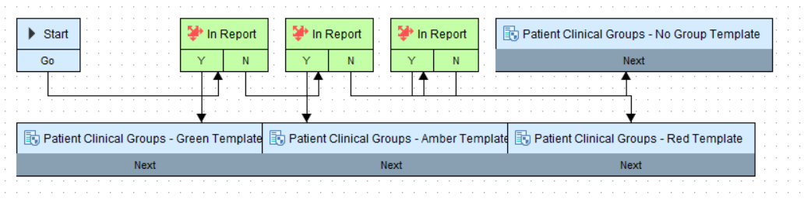

Patient Status Alert

The patient’s record is then labelled using a Patient Status Alert that based on the Clinical Reports outlined above:
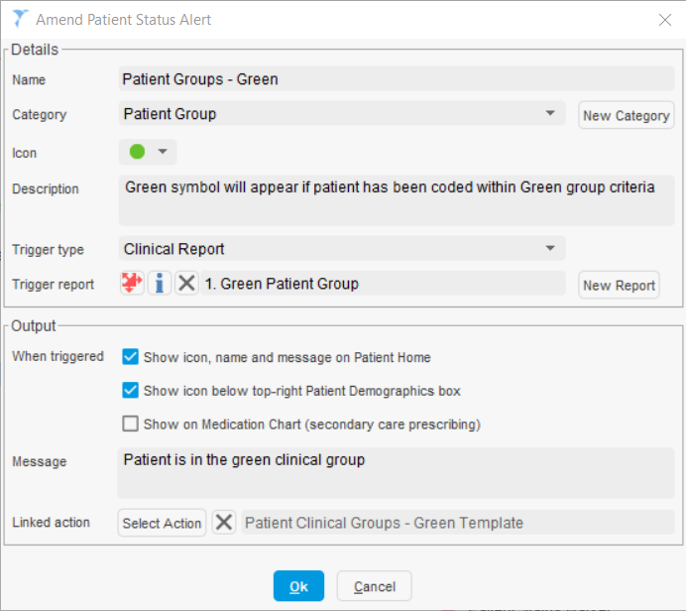
This then shows up on the patient record home page:
