

COVID-19
DOORSTEP ASSESSMENT SERVICE

STANDARD OPERATING PROCEDURE (SOP)

7th April 2020
Version 1
Contents

- Instructions for PHD admin team staff 3

- Instructions for GP practice clinician booking into the home assessment service 3
- The Doorstep Assessment Service process 4

  - Aim of service 4
  - Suitable patients 4
  - Booking into the service 4
  - Contents of the assessment pack 5
  - Actions for those completing the assessment 5
  - Management and follow up 6
  - Practice bypass numbers 6

- Instructions for person delivering assessment packs 6

  - Contents of assessment pack 7
  - Equipment 7
  - Actions to complete assessment 7
  - Important contacts 8

APPENDICES

- Doorstep assessment service pathway 9

- Doorstep assessment service patient how to guide 10

- Primary care assessment of adults with COVID-19 related symptoms 14

- Remote booking instructions 18

- Putting on Personal Protective Equipment (PPE) 19

- Taking off Personal Protective Equipment (PPE) 20

- Routine decontamination of re-usable non-invasive patient care equipment 21

The following SOP is designed to give clear guidance on how all staff are to adhere to the guidance given to protect themselves, patients and members of the public.

- INSTRUCTIONS FOR PHD ADMIN TEAM STAFF

- Assessment pack remote bookable rota held on PHD Community SystmOne Module.
- The rota must be checked by the PHD admin team every 30 minutes at a minimum.
- An email must be sent via NHS.net to the person delivering the packs for any patients booked in after they have gone out on visits. This email must include the following patient information:
  - Name
  - Date of birth
  - Address
  - GP Practice
- The person delivering the pack will email the results to phd.services@nhs.net. This email account must be checked by the PHD admin team every 30 minutes at a minimum.
- A member of the PHD admin team will document the results on SystmOne within 30 minutes of receipt of the email. The results must be entered into the patient’s record using the SystmOne template entitled ‘COVID-19 remote assessment results’. Any actions taken can also be entered as free text into the template.
- The admin staff then needs to send a task to the GP that booked the appointment (marked urgent and red flagged) to state that the results are available.
- The appointment can then be marked as completed.
- If the person delivering the packs has not sent an email for an hour or more, a member of the admin team must telephone them to check they are safe and well.

- INSTRUCTIONS FOR GP PRACTICE CLINICIAN BOOKING INTO THE DOORSTEP ASSESSMENT SERVICE

- Patient is describing symptoms of COVID 19 you think warrant further investigation including: oxygen saturations, temperature and blood pressure.
- Patient MUST:
  - not be able to access the hot clinic themselves
  - be able to understand instructions
  - answer the door
  - use appliances independently.
- Clinician booking the appointment must be available for the next 4 hours and monitor tasks or handover to another clinician who can.
- Clinician to inform the patient they will receive an assessment pack within the next 2 hours. The pack contains clear instructions however the person who delivers the pack can provide assistance from a distance of 2 metres. Inform the patient you will text a link of a video demonstration of the equipment following this call.
- Explain to the patient why you want to do the assessment and how it might change your management plan. Inform the patient you will call them back when you have the results with further management advice.
- Advise the patient to call 999 if they deteriorate whilst waiting for the doorstep assessment.
- The following actions will be taken dependent on the results of the observations:
  - An urgent task will be sent to you that is red flagged to inform you the assessment has been completed:
    - oxygen saturations above 94%
    - heart rate below 110 bpm
    - temperature below 38
    - systolic blood pressure above 100
  - You will receive a call from the person delivering the assessment pack advising you that the patient requires an urgent call:
    - oxygen saturations 90-93%
    - heart rate 110 – 130 bpm
    - temperature above 38
  - systolic blood pressure 91-100
  - You will receive a task to inform you the assessment is completed and 999 has been called:
    - oxygen saturations below 90%
    - heart rate above 130 bpm
    - systolic blood pressure below 90
- Once you have received a task or phone call you are to phone the patient back as soon as possible, but at most within 1 hour with further management advice.
- If a prescription is required this should be sent by electronic transfer prescription to the community pharmacy. Patients should be told that they MUST arrange for someone (not a household member as they will also be self-isolating) to collect the prescription on their behalf and to leave at least 2 hours before it will be available for collection.

- THE DOORSTEP ASSESSMENT SERVICE PROCESS

  - Aim of service
To allow community assessment of those patients with suspected-COVID 19 who are not able to attend the Hot Clinic whilst minimising exposure to primary care workforce.

  - Suitable Patients
- Housebound or without own transport.
- Clinician in general practice has completed a telephone/video assessment and feels obtaining a NEWS score and more specifically an oxygen saturation would change management.
- Symptoms consistent of COVID-19 (see Appendix 3).
- Able to understand instructions and operate the testing appliances independently.

  - Booking into the service
Following the clinical pathway a clinician in primary care feels that obtaining a NEWS score/O2 Saturations would alter a management plan. The clinician:
- Will book the patient into the remote booking clinic at PHD (see Appendix 4).
- MUST be available for the next 4 hours and closely monitor their tasks OR hand over to a colleague to do this.
- Inform the patient that the assessment pack will be delivered to their doorstep within 2 hours (there will be clear instructions included in the pack, but if the patient has difficulty there will be assistance offered from the doorstep at a distance of 2 metres).
- Send a text to the patient with a link to the video explaining how to take the measurements and document them.
- Will explain what the assessment is for and how this will change their management.
- Advise the patient that you will call them back once you have the results of the assessment to advise on management.
- Advise the patient if they worsen whilst waiting for assessment then they should call 999.

The appointment ledger will close at 16:00. After that the clinician should call PHD on 01325 952278 to discuss whether an assessment pack can be delivered.

  - Contents of the assessment pack
- Pulse oximeter
- Sphygmomanometer (electric, with plastic cuff)
- Thermometer
- Laminated instructions on the use of the equipment.
- Laminated sheet to write the results and dry wipe pen.
- Paper sheet for the patient to write down the results for their own records.
- Wipes for cleaning (only if to be used by more than one household member)
- Bag for the equipment to be placed inside once completed.

  - Actions for those completing the assessment
- To be based from Forsyth House.
- Must have business insurance on car. Mileage expenses to be sent to DPCN weekly.
- Mobile phone for work use to be provided.
- Assessment packs to be delivered at the earliest opportunity and within 2 hours of the clinician requesting.
- Pack collected from Forsyth House.
- Drive to patient’s house. Knock on the door and leave the assessment pack on the doorstep. Step back at least 2 metres.
- When the patient answers the door state:
  - “Hello, my name is ……….. Your GP has asked me to drop off this assessment pack to do some monitoring. Can I please just check your name and date of birth? There are instructions inside the pack but if you have any problems please come back out.”
- Wait in the car until the patient comes back out to the door.
- If they need assistance don PPE (see Appendix 5) and give assistance on the doorstep, keeping your distance where possible (a spare set of equipment will be available to assist with this).
- If the patient has completed the assessment without any problems, don apron and gloves and place the assessment bag inside a second bag.
- Take a photo of the laminated results sheet and send this via nhs.net email to phd.services@nhs.net. Once the email has sent take the laminated sheet with their results and place to one side to be cleaned.
- Advise the patient that they will receive a call from their GP (who booked the appointment) within an hour. If they haven’t heard anything they should contact their GP practice.
- Dof any PPE (see Appendix 6). Double bag in clinical waste bag and perform hand hygiene.
- Wearing gloves review results and act accordingly:

Oxygen saturations | Heart rate | Temperature | Blood pressure
>94% | <110 | <38 | Systolic BP >100
Action: | Email results to PHD to be recorded on SystmOne. Send task to GP (urgent and red flagged) to state that assessment completed.
Oxygen saturations | Heart rate | Temperature | Blood pressure
90% - 93% | 110 – 130 | >38 | Systolic BP 91 – 100
Action: | Call GP to advise that observations are concerning and the patient needs an urgent call. Email results to PHD to be recorded on SystmOne and task GP to state that assessment completed.
Oxygen saturations | Heart rate | Temperature | Blood pressure
<90% | >130 |  | Systolic BP <90
Action: | Advise the patient to call 999. Email results to PHD to be recorded on SystmOne. Task GP to state that assessment completed and 999 called.

- Clean laminated sheet and phone.
- Remove gloves then perform hand hygiene.
- Either move on to the next case or return to Forsyth house.
- On return to Forsyth House dispose of used PPE.
- Take bagged used assessment kits into a clinical room. Don PPE and clean all equipment (see Appendices 5 and 7). You MUST ensure the windows are open when cleaning the equipment.

  - Management and follow up
- Once task or phone call received, the referring clinician MUST phone the patient back as soon as possible, but within 1 hour.
- Management as per clinical pathway to be discussed with patient.
- If a prescription is required this should be sent ETP to the community pharmacy. Patients should be told that they must arrange for someone (not a household member as they will be self-isolating) to collect the prescription on their behalf and to leave at least 2 hours before collection.
- Arrange follow up as per clinical pathway.

  - Practice Bypass numbers

Blacketts Medical Practice | 01325 347262
Carmel Medical Practice | 01325 341412
Clifton Court Medical Practice | 01325 469290
Denmark Street Surgery | 01325 241927
Moorlands Surgery | 07983019887
Neasham Road Surgery | 01325 460493
Orchard Court Surgery | 01325 481643
Parkgate Medical Practice | 01325 735005
Rockliffe Court Surgery | 01325 331843
St George’s Medical Practice | 01325 720637
Whinfield Medical Practice | 01325 346674/346679

- INSTRUCTIONS FOR PERSON DELIVERING ASSESSMENT PACKS

You will be supplying the necessary equipment to allow the assessment of people with suspected COVID-19 who are not able to access the Hot Clinic.

Assessment includes:
- oxygen saturation
- pulse using pulse oximeter
- blood pressure using electrical machine
- temperature

  - Contents of assessment pack
- Laminated instructions
- Laminated sheet to record results
- Dry wipe pen
- Paper sheet to record results (for the patient to keep)
- Pulse oximeter
- Electrical sphygmomanometer (with plastic cuff)
- Forehead thermometer

  - Equipment
- Alcohol hand gel
- Disinfectant spray and wipes
- Mask
- Gloves
- Visor
- Gown
- Car seat covers
- Spare bags (to place the bag with the used equipment in after patient contact)
- Clinical waste bag (to place any used PPE equipment)

You will also be provided with a phone and pair of scrubs.

  - Actions to complete assessment
- Ensure the right equipment is in the bag and you have all the other necessary equipment.
- Drive to patient’s house.
- Place the assessment bag at the doorstep, knock on the door and step back at least 2 metres.
- When the patient answers the door introduce yourself:
  - “Hello, my name is ……….. Your GP has asked me to drop off this assessment pack to do some monitoring. Can I please just check your name and date of birth? There are instructions inside the pack but if you have any problems please come back out.”
- Wait until the patient returns to the door
- A spare set of equipment will be available to demonstrate on yourself how to use the equipment. Alternatively if they need assistance don PPE (see Appendix 5) and give assistance on the doorstep, keeping distance where possible.
- Ask the patient to return the bag and laminated sheet with results face up separately on the doorstep.
- Advise the patient that they will receive a call from their GP within an hour. If they haven’t heard anything they should contact their GP practice.
- Ask the patient to shut the door.
- If they have completed the assessment without any problems put the assessment bag inside a second bag.
- Remove any PPE (see Appendix 6). Double bag in clinical waste bag and perform hand hygiene.
- Compare results on the laminated sheets against the reference ranges given (see table below) and act appropriately, either:
  - Email a photo of the results to PHD
  - Call the GP and email a photo of the results to PHD
  - Knock on the door and advise the patient to call 999 and to quote their results. Email a photo of the results to PHD.

Oxygen saturations | Heart rate | Temperature | Blood pressure
>94% | <110 | <38 | Systolic BP >100
Action: | Email results to PHD to be recorded on SystmOne. Send task to GP (urgent and red flagged) to state that assessment completed.
Oxygen saturations | Heart rate | Temperature | Blood pressure
90% - 93% | 110 – 130 | >38 | Systolic BP 91 – 100
Action: | Call GP to advise that observations are concerning and the patient needs an urgent call. Email results to PHD to be recorded on SystmOne and task GP to state that assessment completed.
Oxygen saturations | Heart rate | Temperature | Blood pressure
<90% | >130 |  | Systolic BP <90
Action: | Advise the patient to call 999. Email results to PHD to be recorded on SystmOne. Task GP to state that assessment completed and 999 called.

- Wipe the laminated sheet down with the wipes provided and place in purple bag.
- Place gloves in clinical waste bag and perform hand hygiene.
- Move on to the next case and repeat these steps or return to Forsyth house, dispose of PPE and sterilise equipment (see Appendix 7).

  - Important contacts

PHD | 01325 952278
PHD email | phd.services@nhs.net
Blacketts Medical Practice | 01325 347262
Carmel Medical Practice | 01325 341412
Clifton Court Medical Practice | 01325 469290
Denmark Street Surgery | 01325 241927
Moorlands Surgery | 07983019887
Neasham Road Surgery | 01325 460493
Orchard Court Surgery | 01325 481643
Parkgate Medical Practice | 01325 735005
Rockliffe Court Surgery | 01325 331843
St George’s Medical Practice | 01325 720637
Whinfield Medical Practice | 01325 346674/346679

APPENDIX 1

APPENDIX 2

DOORSTEP ASSESSMENT PATIENT HOW TO GUIDE

Please follow the instructions below to complete a physical self-assessment. If you are having any problems the person who dropped off the kit will be able to help you on the doorstep from a safe distance.

Pulse oximeter
This machine is used to measure your oxygen saturations and your heart rate.

- Place one finger in the rubber opening of the pulse oximeter, with the screen facing towards you.
- Press the blue button on the front once.
- Keep finger still.
- Wait until the numbers stop changing.
- The number on the left is your oxygen saturation; it is underneath ‘%SpO2’.
- The number on the right is your pulse; it is underneath ‘PRbpm’.
- Record your results on the slip of paper provided.
- Remove the device, it will turn off automatically.

In this example:
- Oxygen saturation - 97%
- Pulse - 72
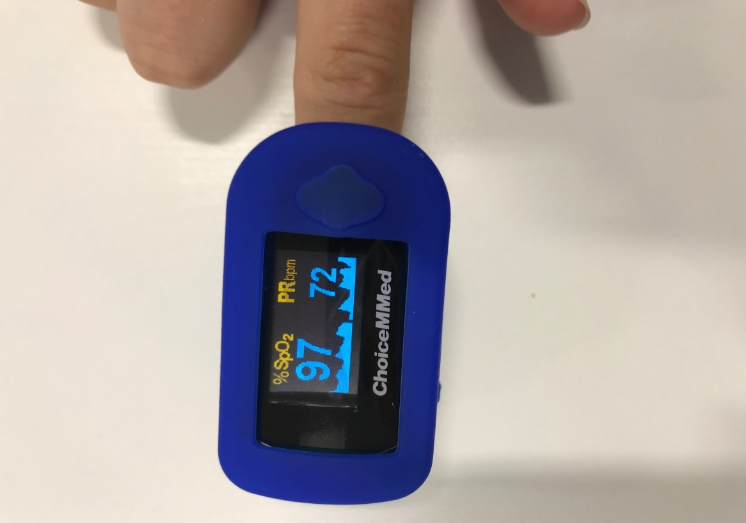

Blood Pressure Machine

- Sitting at a table wrap the cuff on your upper arm using the velcro strap
- Tube side of the cuff should be 1 – 2cm above the inside elbow.
- Once the cuff is in place, rest your arm on the table.
- Press the blue start/stop button.
- Keep still while the cuff inflates, you will feel some pressure on your arm.
- Once the cuff has stopped inflating record your results on the paper provided.

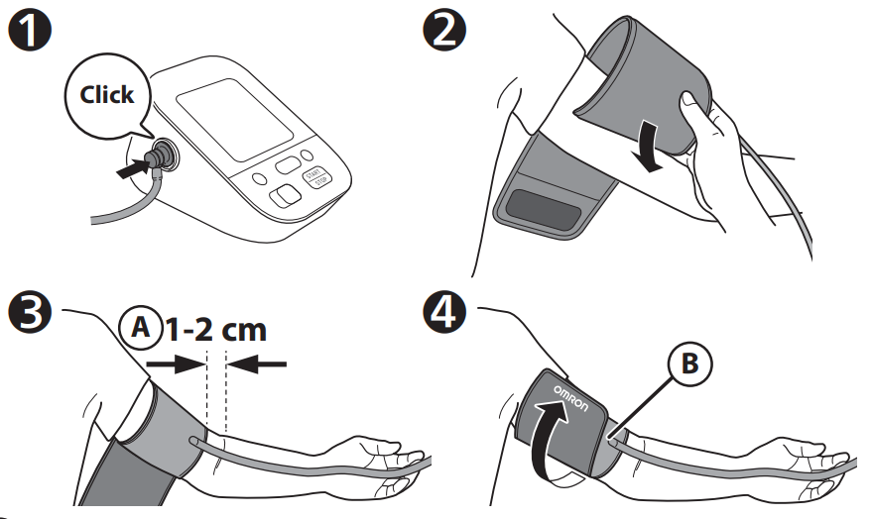

In this example the blood pressure is 109/69.
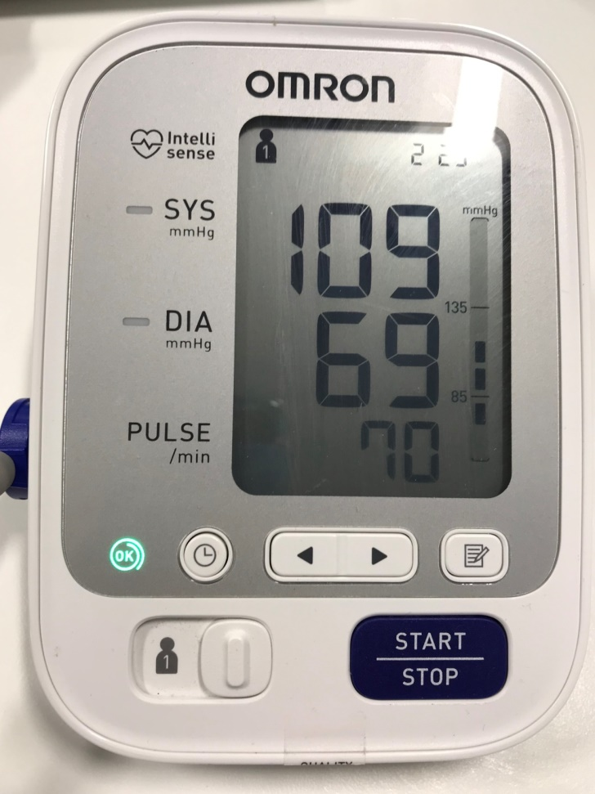

Thermometer

- Aim at your forehead.
- Press the purple button and listen for a beep.
- A result will appear on the back of the device.
- Record your result on the paper provided.

In this example the temperature is 36.3.

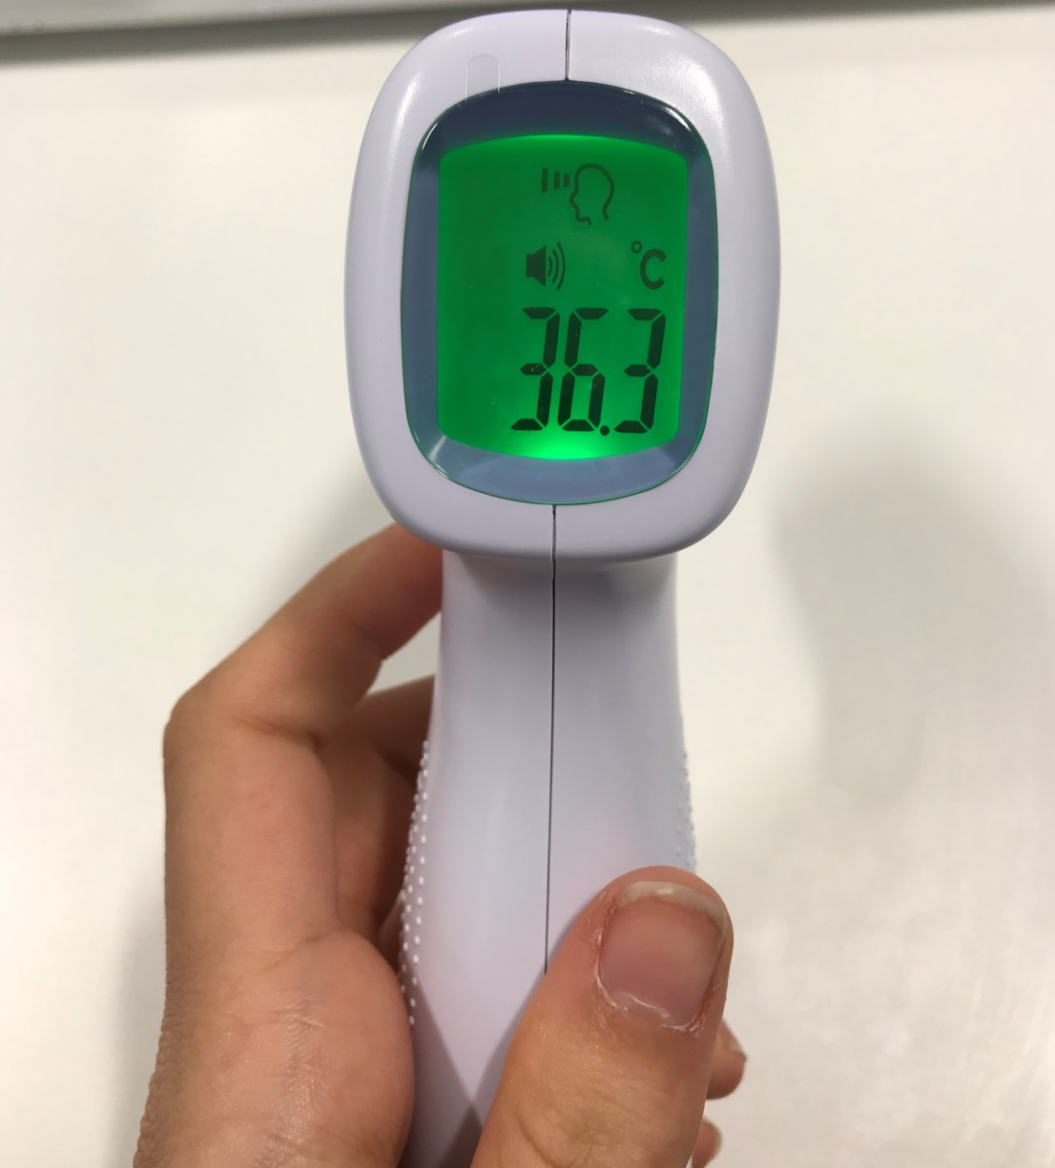

Please document your results on the paper sheet and keep this yourself. Document the results on the wipe clean sheet and leave this on top of the bag on the doorstep.

This is how the sheet should look after you have filled it in:

Once you have finished please place all equipment and instructions back inside the bag and leave on the doorstep.

Your GP will be in contact within an hour. If you haven’t heard anything by then please call your GP surgery. If you become more unwell whilst waiting please call 999.

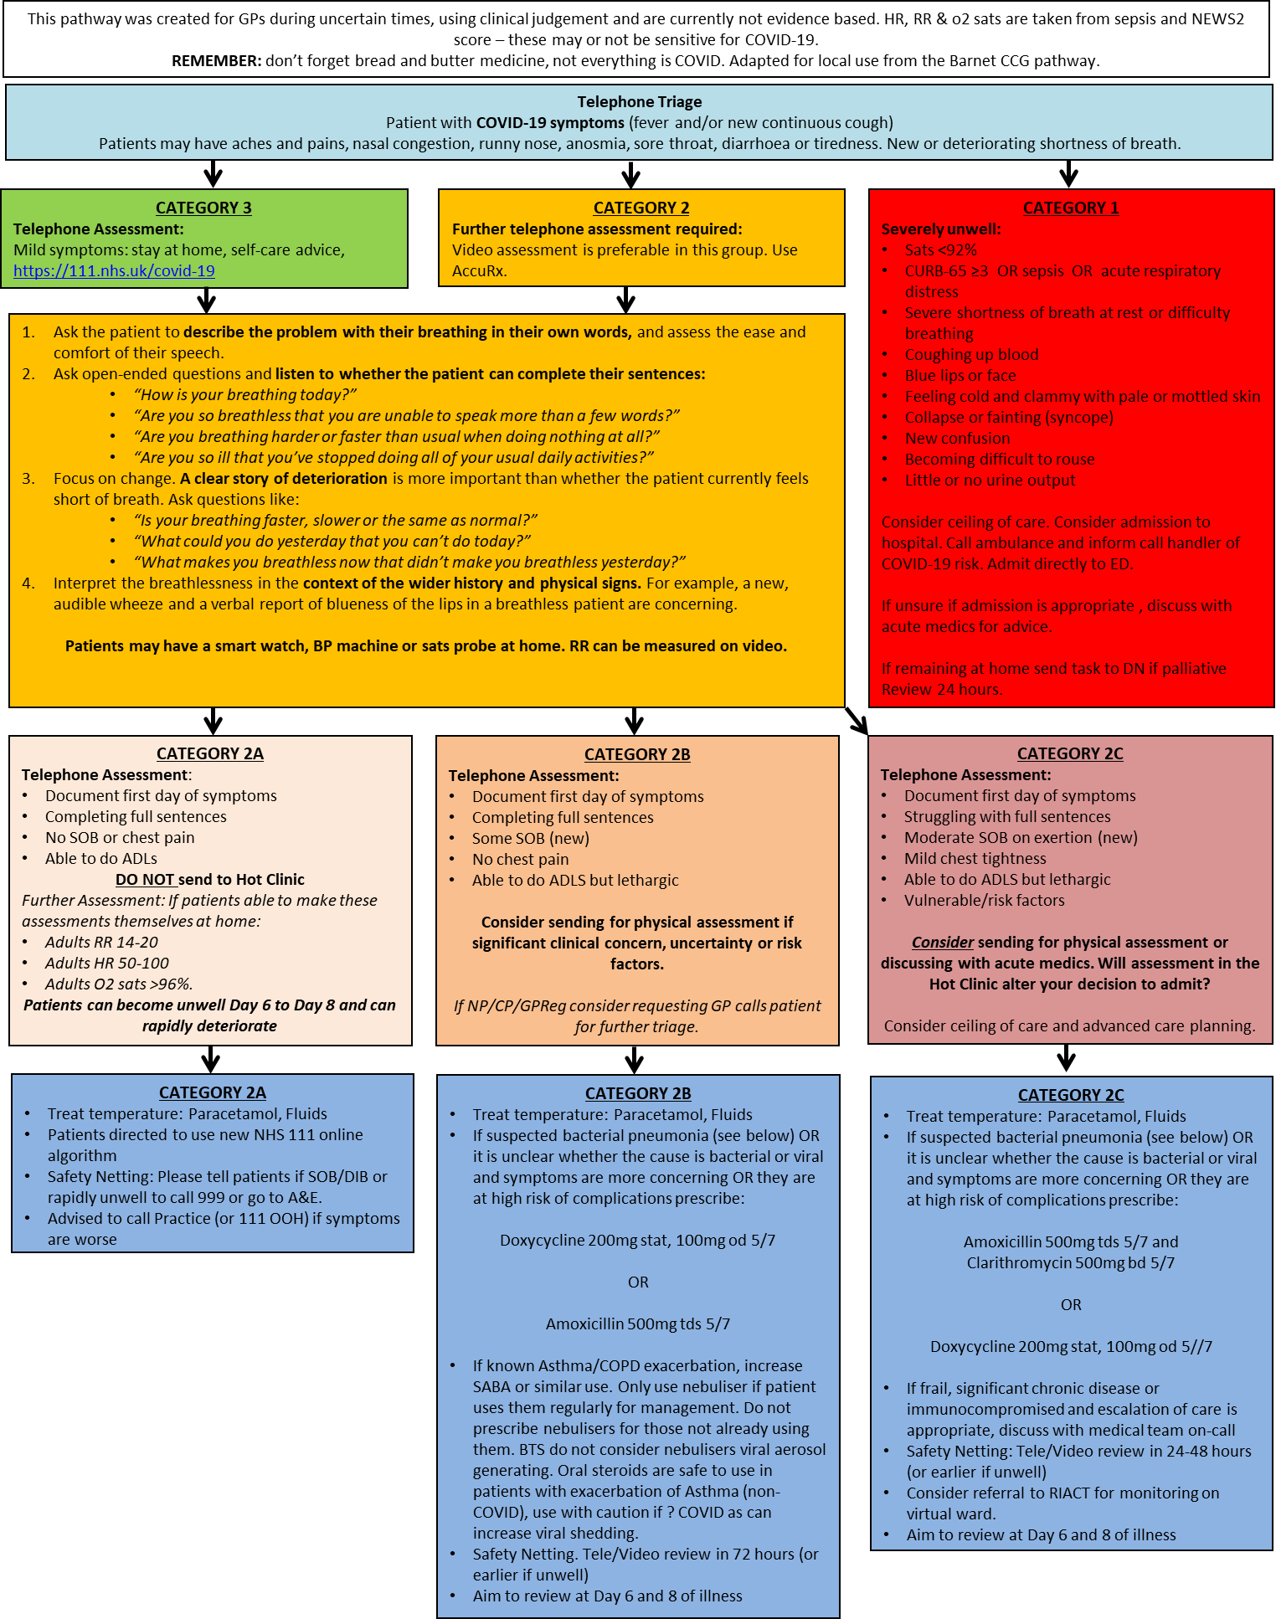
APPENDIX 3

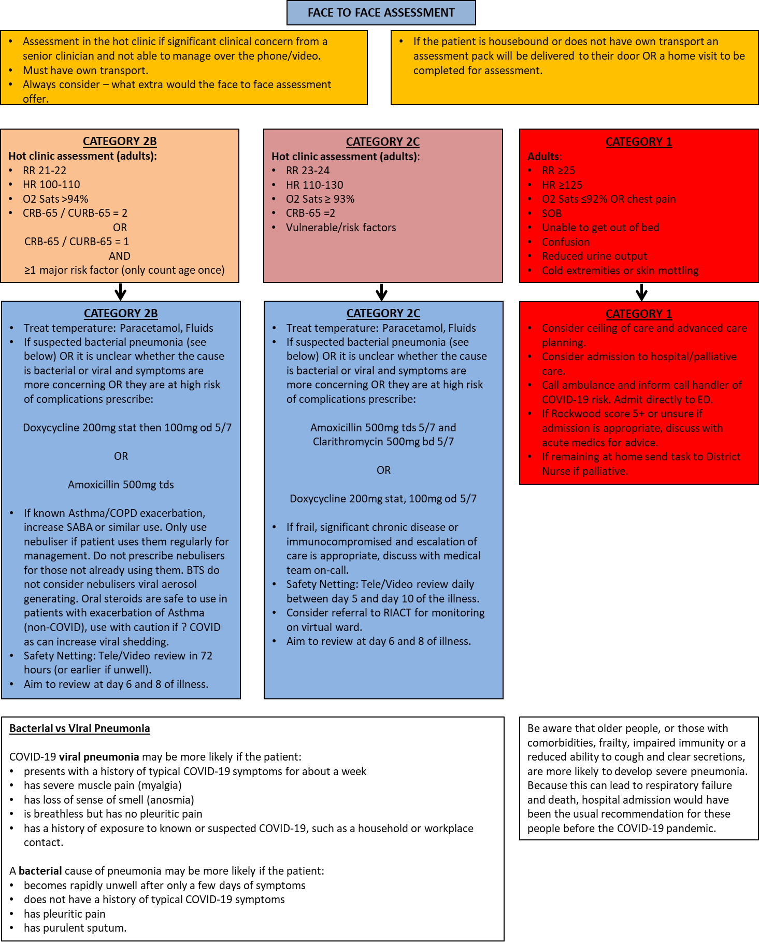

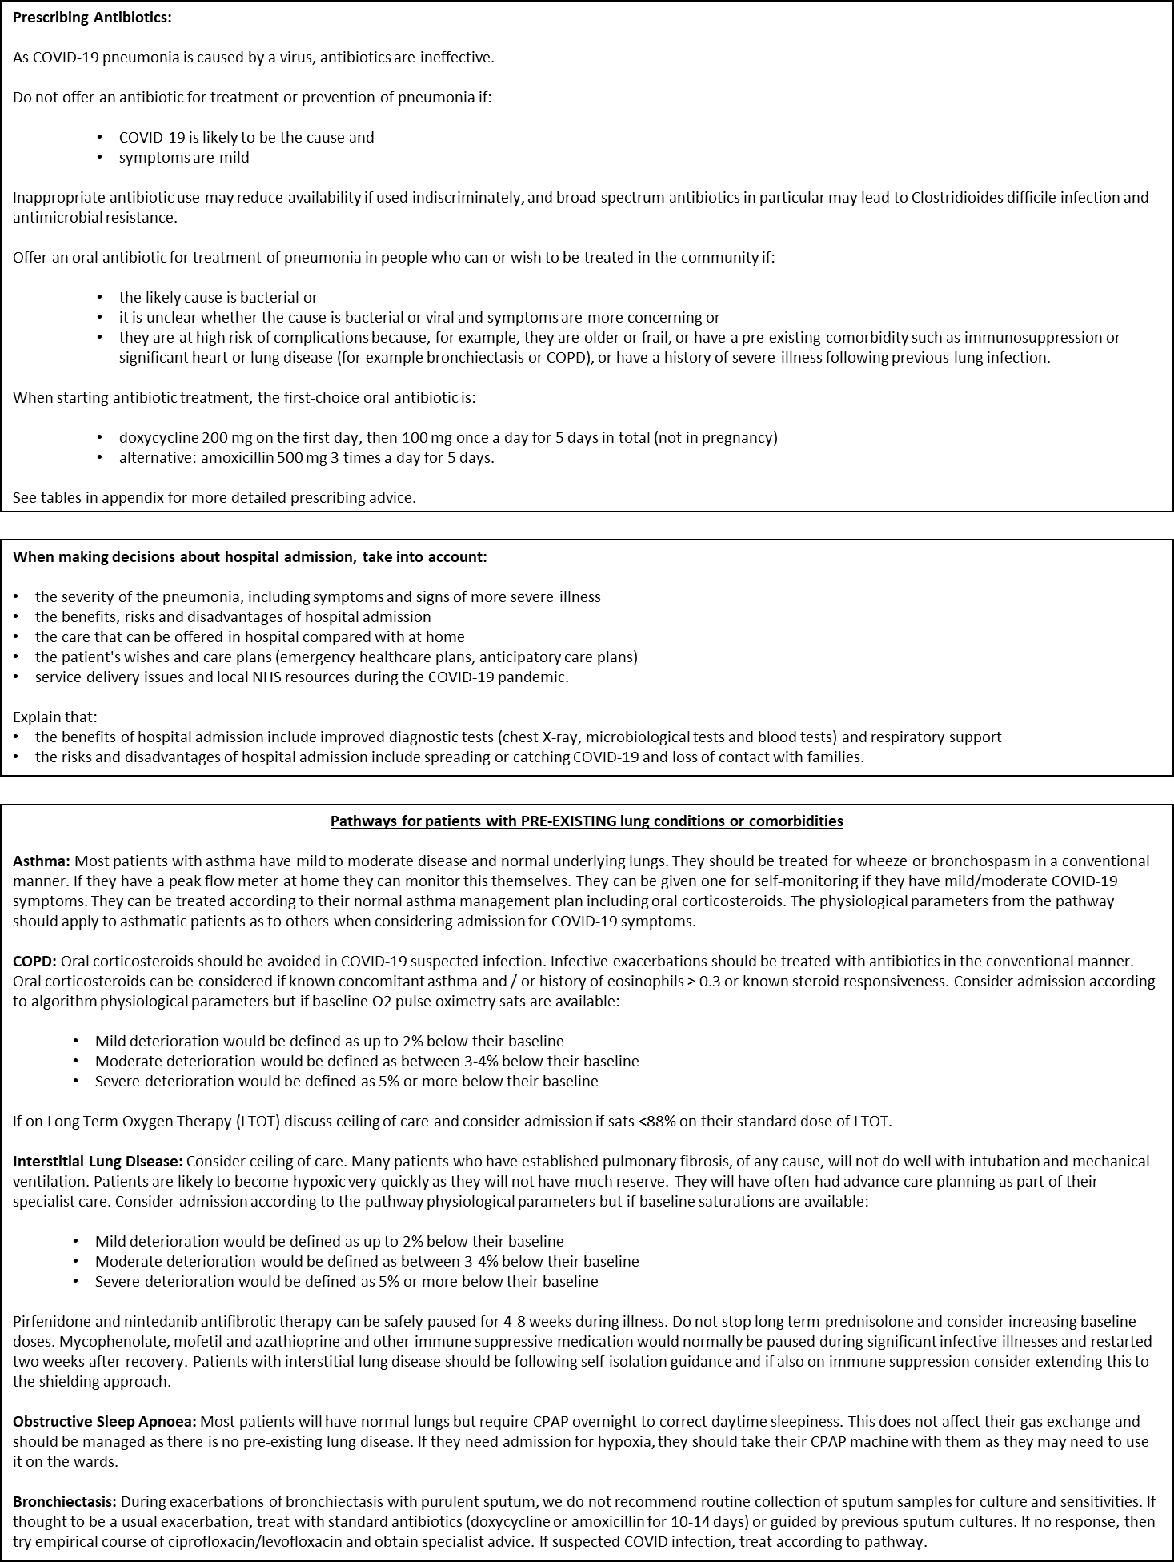

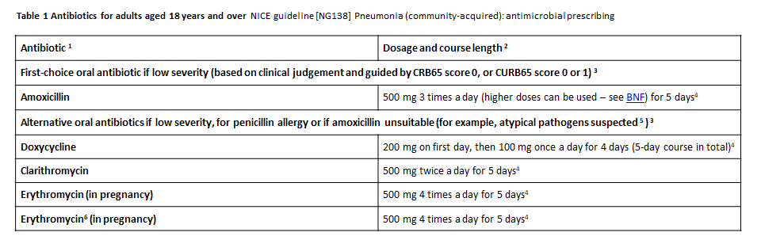

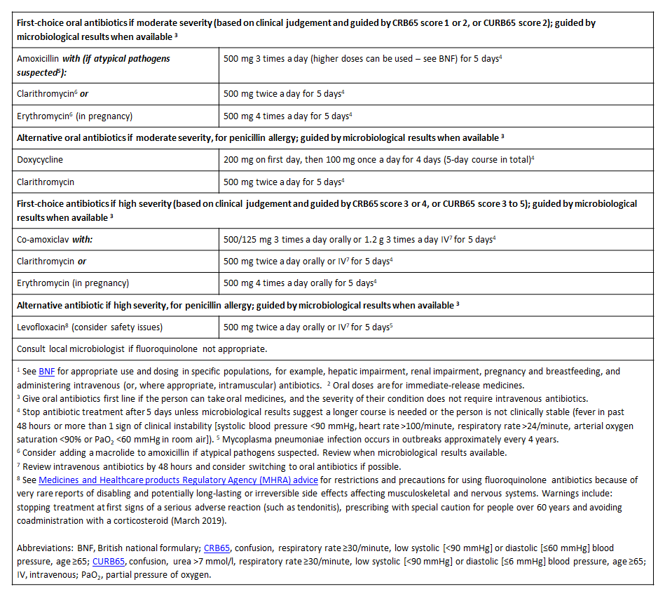

APPENDIX 4

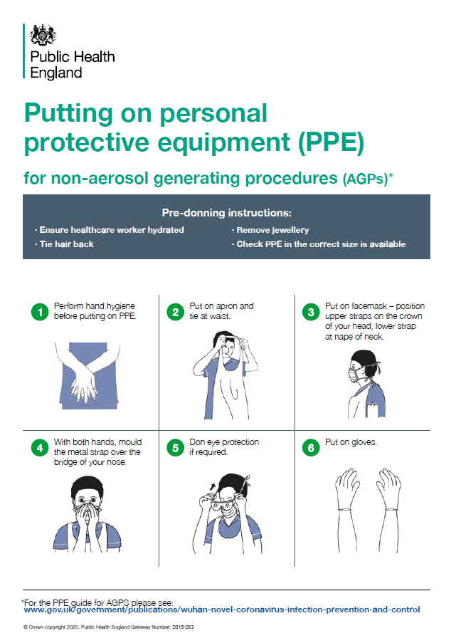
APPENDIX 5

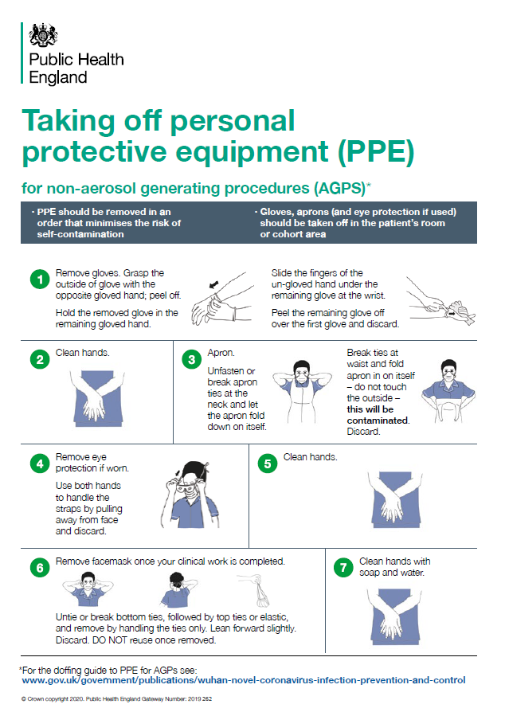
APPENDIX 6

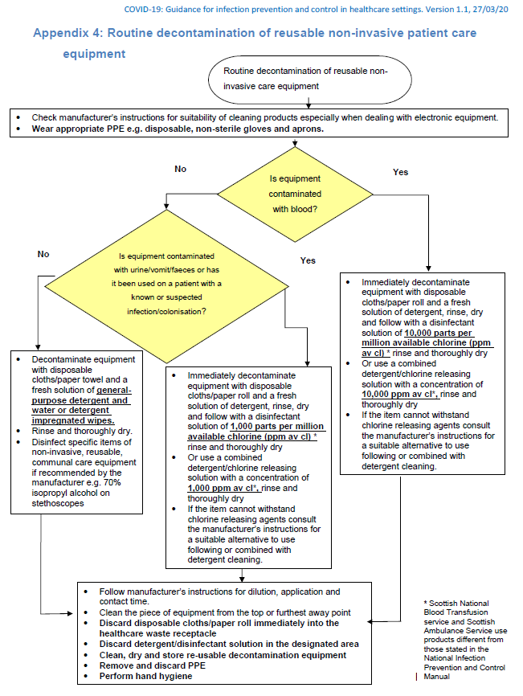
APPENDIX 7

