

COVID-19
HOT SITE CLINICS

STANDARD OPERATING PROCEDURE (SOP)

30th March 2020
Version 3
CONTENTS

- Premises and location 3

- Personal Protective Equipment (PPE) 3

- GP practice staff instructions for booking into Hot Clinics 4

- Clinician instructions for working in Hot Clinics 4

- Clinic pathway 5

- In the event of an emergency 6

- Information Technology (IT) 6

- Cleaning procedure 6

APPENDICES

- Primary care assessment of adults with COVID-19 related symptoms 7

- Rockwood Clinical Frailty Score 9

- NICE COVID-19 rapid guideline: critical care (March 2020) 10

- SystmOne remote booking instructions 11

- PHD Infection Prevention and Control policy 12

- Roth Score 33

- NICE traffic light system for fever in under 5’s 34

- CRB65+ score 35

- Vulnerable groups 36

- Adult Advanced Life Support for COVID-19 patients 38

- Routine decontamination of re-usable non-invasive patient care equipment 39

- COVID-19 patient information leaflet (adults) 40

- COVID-19 patient information leaflet (children & young people) 41

- Hot Clinic staff rota (as at 30/03/2020) 42

The following SOP is designed to give clear guidance on how all staff are to adhere to the guidance given to protect themselves, patients and members of the public.

- PREMISES AND LOCATION

- Forsyth House, 20 Woodland Road, Darlington, DL3 7PL.
- Clinic telephone number 01325 952278.
- Patients can park in any of the parking spaces at Forsyth House. Disabled parking is also available.
- The Forsyth House car park is also available for clinicians working in the Hot Clinic. Alternatively three parking spaces are available for use at Blacketts Medical Practice however a parking permit must be collected from PHD in advance. Nearby on-street parking is also available.
- The Hot Site is well signposted with signs advising patients NOT to touch surfaces or use the toilet and to telephone the clinic before entering the building.
- Patients to be under supervision at all times when in the clinic.
- All entrance doors to be left open so patients do not have to touch the doors.
- There must be no leaflets/magazines to be left out in any areas.

- PERSONAL PROTECTIVE EQUIPMENT (PPE)

All clinicians working within the Hot Site must adhere to the following:

- Underpin the PHD infection control procedures (see Appendix 5).
- Own clothes to be worn to work.
- Scrubs to be changed into before the clinic begins. If scrubs not available clinicians must bring an additional change of clothes.
- PPE is provided and must be worn, this includes:
  - Gloves
  - Plastic apron
  - Plastic glasses
  - Surgical mask/FFP2 mask
- PPE to be changed after every patient contact and the room MUST also be cleaned following procedure.
- FFP2 masks only to be worn for highly suspicious COVID-19 patients or where throat examination essential. They are NOT to be worn for every patient.
- Ensure correct donning (on) and doffing (off) procedures are followed (see Appendix 5).
- Clinicians are required to change into their own clothes for breaks and use of communal areas to reduce the risk of spreading potential infections.
- Scrubs must be removed before leaving the consultation room and placed in a water soluble alginate bag, which should then be placed in a clear polythene bag and secured (bags provided by PHD).
- Scrubs should be laundered (by clinician if own scrubs, by PHD if provided at clinic):
  - separately from other household linen
  - Place the water soluble bag directly into the washing machine
  - in a load not more than half the machine capacity
  - at the maximum temperature the fabric can tolerate, then ironed or tumble dried.

- GP PRACTICE STAFF INSTRUCTIONS FOR BOOKING HOT CLINIC APPOINTMENTS

- Patients must be triaged by a senior clinician in their registered GP practice prior to booking into the Hot Clinic.
- If a nurse practitioner/clinical practitioner/GP Registrar has triaged the case, please consider a second call from a senior GP to ensure that the Hot Clinic is the only option.
- Criteria for booking into Hot Clinics:
  - New Persistent cough
  - Fever of 37.8 and above
  - Suspected COVID 19 infection and unable to manage over the phone.
    - Every effort must be made to manage the patient over the phone. Consider video consultation and E-Consult with photos.
    - Refer to clinical pathway
    - If the patient is acutely unwell consider a direct admission via ED – only send to the Hot Clinic if you are uncertain.
- Appointments to be booked via SystmOne remote booking (instructions in Appendix 4).
- Patients must be able to make their own way to the hot site – they must not use public transport or a taxi. If this is not possible a home visit assessment must be undertaken by the registered GP.
- Clinics run Monday – Friday, 10.00am – 4.00pm, two clinics per day (GP/Nurse Practitioner)
- Appointment duration is 30 minutes.
- Appointments become available for booking at 3:30pm for the following day’s clinic. If the case is felt to be more urgent they should be advised to attend the Respiratory ED department or a home visit should be undertaken.
- Ensure an up to date mobile number is on the booking and an up to date community pharmacy is allocated.
- Instruct the patient as follows:
- On arrival wait in the car park and telephone the Hot Clinic (01325 952278) to report their arrival.
- Wait outside in the car park until they are collected by the clinician. They must not enter the building before this.
- When called the patient is to enter the building ALONE (unless translator or carer NEEDED).
- The clinician will give the patient a face mask to put on before entering the building. The patient will then be taking directly to the consulting room.

- CLINICIAN INSTRUCTIONS FOR WORKING IN HOT CLINICS

- Please attend at least 15 minutes before your shift is due to start. Clinician responsible for familiarising themselves with location of equipment and emergency procedures. Assistance will be offered with this.
- Log in details for Windows:
  - Username- Phd.Locum
  - Password- 234Getwell
- Clinician must have their smartcard to access the clinical system
- Clinician to attend wearing own clothes, change into scrubs on arrival to the clinic (alert Jehanne Readman in advance if you do not have access to any) and change out of scrubs before leaving. Scrubs to be placed inside water soluble bag then into a clear plastic bag (both available in the under-sink cupboard inside the clinical room). Launder as per instructions in the infection control policy.
- Clinicians must be bare below the elbow and long hair should be tied back. Nail varnish is not allowed.
- Sphygmomanometer, pulse oximeter and thermometer will be provided. Clinician to bring any further clinical equipment with them.
- Do not measure peak flow. Do not examine throats.
- Clinician is to review records BEFORE the patient enters the room to limit the time of contact.
- When ready the clinician will phone the patient and advise them that they will meet them at the front door with a mask.
- Clinicians must be in full PPE before collecting the patient from the car park.
- Clinicians to give patient a surgical face mask to put on before they enter the building.
- If the patient is a child, the parent/carer should also wear a mask.
- Once the patient leaves remove PPE as per guidance and perform hand hygiene.
- Then, wearing gloves and an apron, ALL surfaces in the consulting room must be wiped down between each patient. Remove the PPE and repeat hand hygiene.
- COVID-19 auto-consultation must be used to read code ‘suspected coronavirus infection’ (XaaNq) for suspected cases.
- Clinicians will document the consultation on PHD S1 community module. A COVID-19 template is available found by clicking on the GMS box under the patient demographics.
- For suspected COVID-19 cases hand out the patient leaflet with safety net information.
- Admission pathway for suspected COVID-19 is to advise patient to immediately go to Respiratory ED department at Darlington Memorial Hospital where they will be given an early review by a senior clinician.
- For admission of a child please discuss with paediatric registrar on-call.
- Children with suspected COVID-19 are to be managed in line with the NICE Guidance Fever in under 5s: assessment and initial management (https://www.nice.org.uk/guidance/ng143).
- Medication should be prescribed in the patient’s registered practice SystmOne module and sent ETP. If ETP is not available, an urgent task must be sent to the registered practice to request the prescription.
- Four SystmOne modules can be open at a time. Once the first system has fully opened, double click on the SystmOne icon and a second module will open. Clinicians are able to contribute to work in their usual practice if the Hot Clinic is quiet.
- Please leave promptly at the end of your session so full decontamination can commence at 4.00pm.

SEE APPENDIX 1 FOR TELEPHONE AND FACE TO FACE ASSESSMENTS OF ADULTS WITH COVID-19 RELATED SYMPTOMS

- CLINIC PATHWAY

- Patient will have been advised to remain outside in the car park until collected by the clinician for assessment.
- The clinician will give the patient a surgical mask at the main door to put on before entering the building and will then be taken directly to the consulting room. Patients must not sit in the waiting room or report to the reception desk.
- A physical assessment is likely – clinicians must ensure PPE remains in place.
- Throat examinations MUST NOT be undertaken.
- Management to be discussed and plan on next steps giving clear guidance to patient.
- Patient is to leave wearing the mask and advised not remove until out of the building. They will be asked to put it in their own bin at home by tying it up in a bag.
- The consulting room MUST be cleaned by the clinician between patients.
- Self-isolation advice to be given as per government guidelines.
- For suspected COVID-19 cases hand out the patient leaflet with safety net information.

- IN THE EVENT OF AN EMERGENCY

- Press the Green Button panic button (physical button on desk and button on PC desktop).
- Shout for help.
- Receptionist to bring emergency equipment including oxygen to the door of the consultation room.
- Remain 2 meters away at all times and DO NOT ENTER THE ROOM WITHOUT PPE – if possible ascertain if an ambulance is needs to be called and do so if needed. Communicate:
  - Location
  - Male/female adult/child
  - Suspected COVID-19
  - They will ask if the patient is alert/breathing
- Receptionist then to don PPE and enter the room to assist clinician as needed.
- Clinician to document any actions taken on SystmOne.

- INFORMATION TECHNOLOGY (IT)

- Records should be:
  - Accurate
  - Clear
  - Contemporaneous
  - Complete
  - Avoid jargon
  - Clear plan
  - Clear documentation of communication with patient
- PHD confidentiality policy to be adhered to.
- Ensure appropriate coding for COVID-19 is used. This is essential to ensure that patients are traceable if required to return for further testing as governance guidance may change and patients may need to be recalled.
- PHD Wi-Fi password: PHD952278

- CLEANING PROCEDURE

Please comply with the COVID-19 Infection Control Procedure (see Appendix 5) and in addition:
- Reception surfaces to be cleaned with disinfectant hourly, including all door handles from entrance to reception.
- Full decontamination cleaning of all used spaces after the clinic is completed before any other activity commences as per policy.
- The clinician will be responsible for the cleaning of all surfaces, floors and equipment after every patient.
- Work surfaces in clinical rooms to be totally clear apart from essential IT and clinical equipment

APPENDIX 1

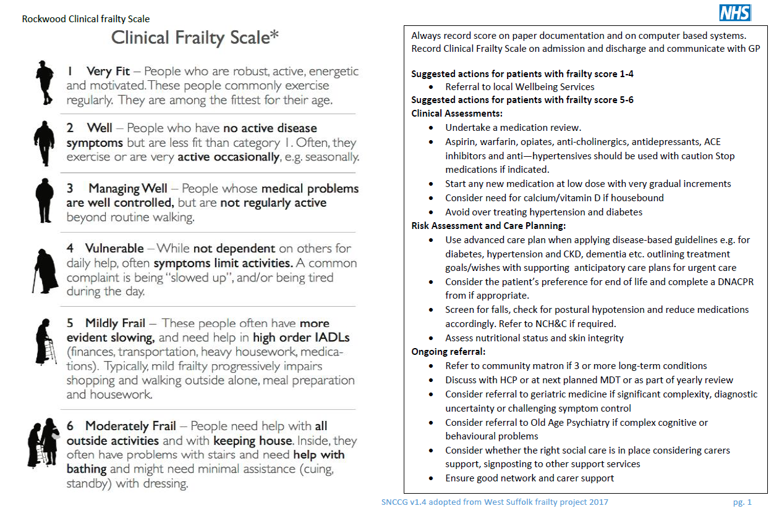
APPENDIX 2

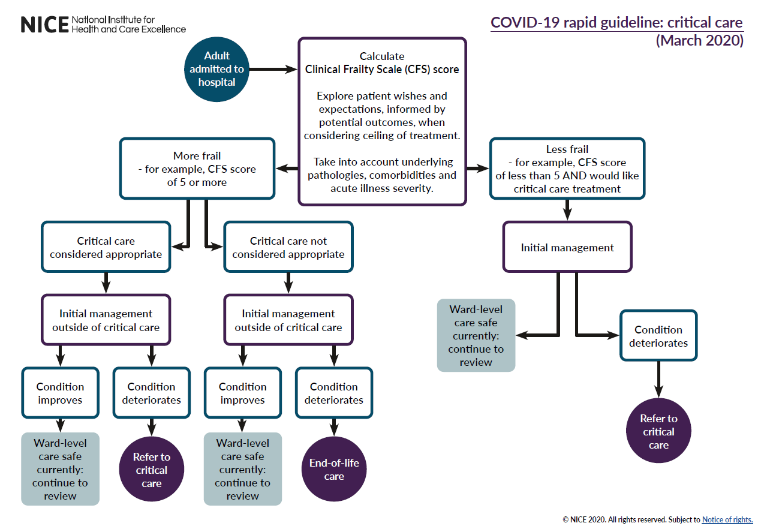
APPENDIX 3

APPENDIX 4


APPENDIX 5

POLICY FOR GENERAL INFECTION PREVENTION AND CONTROL

Document Control

- Confidentiality Notice

This document and the information contained therein is the property of Primary Healthcare Darlington Ltd.

This document contains information that is privileged, confidential or otherwise protected from disclosure. It must not be used by, or its contents reproduced or otherwise copied or disclosed without the prior consent in writing from Primary Healthcare Darlington Ltd.

- Document Details

Classification: | Clinical Policy
Author and role: | Sue Dixon, Infection Control Nurse
Organisation: | Primary Healthcare Darlington
Document Reference: | POL/022
Current Version Number: | 3.0
Current Document Approved By: | Dr Amanda Riley
Date Approved:

- Document Revision and Approval History

Version | Date | Version Created By | Version Approved By | Comments
1.0 | 3/7/2017 | Review | Janet Robson
2.0 | 4/7/2018 | Review | Janet Robson

Policy Validity Statement

This policy is due for review 12 months from the latest date shown above. After this date, policy and process documents may become invalid.

Policy users should ensure that they are consulting the currently valid version of the documentation.

Contents

- Policy Statement

- Uniform

- Hand hygiene

- Performing hand hygiene

- Use of Personal Protective Equipment

- Needle stick injury

- Body fluid spillages

- Infectious diseases

- Staff cleaning responsibilities

- Handling of specimens

- Notifiable diseases

- References

APPENDICES

- COVID-19 guidance for infection prevention and control in PHD clinics

- Handwashing procedure

- Hand rub procedure

- Putting on Personal Protective Equipment

- Taking off Personal Protective Equipment

This document sets out the surgery policy on infection prevention and control procedures at PHD Forsyth House.

- Policy Statement

The practice is committed to the control of infection and prevention within the ground floor level of Forsyth House and in relation the procedures carried out within it and is responsible for ensuring that appropriate systems and processes are in place within the practice to protect patients and staff, minimise the risk of infection and reduce the risk of cross infection. Good management and organisational processes are crucial to ensure that high standards of infection prevention including cleanliness are maintained.

The practice will maintain their part of the premises and equipment providing facilities and the financial resources wherever possible or practicable. PHD will seek to use washable or disposable materials for items such as soft furnishings and consumables e.g. seating materials, wall coverings, couch rolls, hand towels and bed curtains ensuring these are replaced regularly to ensure that all reasonable steps are taken to reduce or remove infection risk as far as is reasonably practicable.

This policy applies to all PHD employees irrespective of age, sex, gender reassignment, sexual orientation, race, religion or belief, disability, marriage and civil partnership or pregnancy and maternity, provided that the matter at issue is within the control of the surgery. This policy applies to those employed on a permanent, temporary or fixed term contracts. It is recognised that sections of this policy will be relevant to some members of staff more than others.

PHD has a responsibility to oversee the implementation of this policy and to ensure that action is taken to meet the company's obligations to minimise the risks of infections and comply with national guidance and legislation. Managers have a responsibility to follow this policy and to act on issues of poor conduct in an appropriate and timely manner, as well as assist and support employees to meet the required standards of conduct. All employees have a responsibility to familiarise themselves and act in accordance with this policy. The Infection Prevention and Control Lead are/is responsible for the provision of advice and/or support to managers and employees in relation to the application of this policy.

Standard infection prevention and control (IPAC) precautions underpin safe practice, offering protection to both staff and patients from healthcare related infections.

This policy will cover the following specific areas of standard infection prevention and control precautions:

- Uniform
- Hand Hygiene
- Personal Protective Equipment
- Sharps Injuries
- Body Fluid Spillages
- Infectious Diseases
- Handling Patient Specimens
- Notifiable Diseases

- Uniform

Uniforms provided by PHD for clinical staff must be changed daily and washed at a minimum temperature of 40 degrees. They are provided to give an element of protection to the wearer and to promote a professional and corporate image to the public. See uniform policy for further information and guidance.

Staff working in clinical areas must adopt ‘bare below the elbows’ and wear short sleeves or sleeves that can be rolled up to the elbows.

Staff in clinical areas must not wear artificial nails or nail extensions, wrist watches, wrist and fitness bands, bracelets and rings (except one plain banded ring). Fingernails must be short and clean. Hair must be above the collar, and if long tied back.

- Hand Hygiene

Hand decontamination is simple and the most effective way that staff can prevent the transmission of infection and protect themselves. Micro-organisms found on the skin, Resident (Normal) Flora forms part of the body’s normal defence mechanisms and protects the skin from invasion by more harmful micro-organisms. These rarely cause disease and are of minor significance in routine clinical situations.

Transient Flora are acquired by touch, e.g. touching patients, from the environment, equipment, laundry, etc. These are located superficially on the skin and are readily transmitted to the next thing touched, and are responsible for the majority of healthcare associated infections. These are easily removed by effective hand decontamination.

Hand washing is the single most important means of controlling the spread of infection. The micro-organisms on the hands are not firmly attached to the skin and can usually be removed quickly and effectively with soap and water. Hands are a repository for infectious organisms and healthcare staff have the greatest opportunity to transfer these organisms both between patients and between different procedures for the same patient.

- Hands should be decontaminated either by washing or use of hand gel
- Before contact with all patients, particularly susceptible sites e.g. wounds
- Before donning gloves
- Before clean/aseptic procedures
- After removing disposable gloves (gloves are not a substitute for effective hand washing – they can develop holes whilst in use and hands can become contaminated on removal of gloves)
- After body fluid exposure/risk
- After direct patient contact
- After handling contaminated waste
- After visiting the toilet
- Before starting or leaving work

The purpose of hand hygiene and adequate drying in clinical settings is to remove microbial contamination that has been acquired during contact. The hands should be dried properly after washing because this reduces the number of organisms subsequently released from the hands. Where possible, dedicated hand washing sinks should be available in clinical areas and fitted with elbow operated mixer taps. If elbow operated taps are not available, then taps should be turned off, after drying hands, with a clean, dry paper towel.

Washing the hands with plain liquid soap and water is adequate for most routine activities. Hand washing with soap lifts transient micro-organisms from the surface of the skin and allows them to be rinsed off.

Liquid alcohol hand rub/gels: these may be used in place of soap and water if hands are visibly clean. They are especially useful if hand washing and drying facilities are inadequate, or where there is a need for rapid or frequent hand washing. These should not be left in unsupervised areas, as they can be toxic if ingested

Alcohol hand rubs are effective for hand hygiene in all patient care situations except when:

- Hands are visibly soiled
- After removing disposable gloves
- There is direct hand contact with any body fluids
- Failure to don gloves or gloves in these instances, then hands should always be washed with liquid soap and water.

- Performing Hand Hygiene

Wet hands under running water. Dispense one dose of liquid soap into a cupped hand. Wash hands vigorously for 20 seconds covering all surfaces of the hands, nails and wrists. Rinse hands thoroughly under running water. Turn off taps using elbows (or paper towel if taps are not elbow-operated. Dry hands with disposable paper towels the preferred option for use in communal settings. These should be conveniently placed close to hand washing facilities in a wall-mounted dispenser. Foot operated bins should be used to dispose of paper towels to reduce the risk of re-contamination of hands.

Alcohol Hand Rub/gels – Dispense required amount of product onto visibly clean, dry hands. Ensure enough product is dispensed to cover surfaces of hands. Rub vigorously until dry.

Please note that frequent hand washing and using hand gels may cause the skin to dry and crack. Moisturiser should be used to prevent this as cracks or breaks in the skin can allow microbes to pass through the skin barrier, and therefore increase the infection risk.

- Use of personal protective equipment

The choice of personal protective equipment selected must be based on a risk assessment on anticipated exposure to blood and body fluid during the particular activity. Many clinical activities involve no direct contact with body fluid and do not require the use of protective clothing, e.g. taking a pulse, blood pressure or temperature. Other procedures may result in contamination of the hands or clothing and require the use of gloves, a plastic apron, goggles or face visor, e.g. wound care, venepuncture, handling specimens or during specific treatment.

Gloves used for direct patient care:

- must conform to current EU legislation (CE marked as medical gloves for single use)
- should be appropriate for the task
- must be the correct size

Gloves must be worn for invasive procedures, contact with sterile sites and non-intact skin or mucous membranes, and all activities that have been assessed as carrying a risk of exposure to blood, body fluids, secretions or excretions, or to sharp or contaminated instruments.

Gloves must be worn as single-use items. They must be put on immediately before an episode of patient contact or treatment and correctly removed as soon as the activity is completed. Gloves must be changed between caring for different patients, and between different care or treatment activities for the same patient. Gloves must be disposed of correctly in the appropriate bin.

Hands should be decontaminated:

- Before donning gloves, washed with soap and water and dried
- After removal, as they may be punctured, and because hands are easily contaminated as the gloves are being removed

Note: gloved hands should not be wiped with any form of alcoholic substance nor washed as this is not a substitute for hand washing.

Ensure that gloves used for direct patient care that have been exposed to body fluids are disposed of correctly in accordance with current local policy.

Alternatives to latex gloves must be available for patients, carers and healthcare workers who have a documented sensitivity/allergy to latex.

Do not use polythene gloves.

Glove Removal: Grasp the glove in the palm with the opposite gloved hand and slowly withdraw hand outside of the glove. Hold the removed glove in the gloved hand. Slide the fingers of the ungloved hand under the remaining glove at the wrist. Peel the second glove off over the first glove. Dispose of into appropriate waste bin.

Disposable Plastic Aprons: The front of the body is the part most frequently contaminated.

- A disposable plastic apron is to be worn when delivering direct patient care, if there is a risk that clothing may be exposed to blood, body fluids, secretions or excretions

- Disposable plastic aprons are to be used as single-use items, for one procedure or one episode of direct patient care and ensure they are disposed of correctly.

Apron removal: Break ties at neck and allow apron to fold over. Pull apron away from waist touching inside only and pull to break. Fold or roll into a bundle. Dispose of into appropriate waste bin. Do not leave the room wearing the apron.

PPE: should be removed in an order that minimises the potential for cross contamination. Hand hygiene should be performed immediately after removing all PPE.

- Needle stick Injury

Involves needles or sharp-edged instruments which are likely to be contaminated by blood or body fluids and which may cause laceration or puncture wounds. Spillage of blood or body fluids on to intact skin needs to be washed off with soap and water, but further action is not required. No further action will be needed if it is evident that the incident was not a risk for transmission of infection, for example if body fluids contaminated intact skin only or that the needle did not penetrate the subject's skin.

Almost all needle stick injuries can be avoided by safe working practices, but if an injury does happen, the following action must be taken immediately:

Encourage bleeding of the injured area and gently squeeze the surrounding skin for a few seconds. (Do not suck the puncture wound). Wash the affected skin area gently with plenty of soap and running water. Cover the wound with a suitable dressing. If mouth or eye(s) are exposed, irrigate with eyewash, sterile saline, or tap water for 1-2 minutes. If contact lenses are worn, irrigation should take place before and after removing the lenses. Clean lenses in normal manner before re-insertion. Inform Surgery manager and complete an incident form.

If the source is known and strongly suspected to be HIV positive, contact the consultant microbiologist on call.

DO NOT re-sheath needles! Ensure trays and trolleys are cleared with bin close by, Do not walk about with sharps in your hand.

- Body Fluid Spillages

To reduce the risk of body fluid spillages:

- Vomit bowls must be available in all clinical areas
- Toilets must be clearly signposted
- If body fluids are spilled in a clinical room, the consulting healthcare worker is responsible for cleaning it up. If a large or risky spill, consider moving rooms and ensure contract cleaners are aware to deep clean the room.
- Spillage in public area - the nursing team to be responsible for managing the spillage with the support of the reception team.
- Body fluid spillage kits should be available to reception team and clinical rooms

- Infectious Diseases

Diarrhoeal illness including Norovirus and Clostridium difficile: If a provider of health and social care is experiencing an outbreak of diarrhoea or vomiting as a result of Norovirus, Staff should refrain from visiting unless the visit is essential or the areas affected can be avoided. On the occasions when staff are required to visit the standard IPAC precautions detailed in this policy must be adopted.

Any member of staff who has diarrhoea or vomiting should refrain from work until clear of symptoms for 48 hours, and feel well.

Influenza-like illness: Staff and visitors should be encouraged to minimise potential influenza transmission through good respiratory hygiene measures.

Hands should be kept away from the eyes, mouth and nose. Disposable, single-use tissues should be used to cover the nose and mouth when sneezing, coughing or wiping and blowing noses. Try to avoid coughing and sneezing into your hands, instead use a bent elbow. Used tissues should be disposed of promptly in the appropriate waste bin and hands washed immediately afterwards.

Tissues, waste bins (preferably lidded and foot operated) and hand hygiene facilities should be available for Staff and visitors. Hands should be cleaned (using soap and water if possible, otherwise using alcohol hand rub) after coughing, sneezing, using tissues or after any contact with respiratory secretions and contaminated objects.

If a provider of health and social care is experiencing an outbreak of influenza, Staff should refrain from visiting unless the visit is essential or the areas affected can be avoided. On the occasions when staff are required to visit the standard IPAC precautions detailed in this policy must be adopted.

COVID-19: all staff should adhere to the World Health Organisation guidelines and PHDs handwashing and hygiene policy, this has been proven to be the most significant tool to prevent the spread of this virus. Single use patient devices should be used, eg spirometry, thermometer probe covers. Blood pressure cuffs should be wiped down between patient use. Any staff exhibiting symptoms such as feeling unwell, fever, cough and shortness of breath MUST inform their line manager and self-isolate. If symptoms worsen then medical advice should be sought. Avoid touching eyes, nose and mouth.

- Staff Cleaning Responsibilities

Each member of Staff is responsible for:

- Leaving their workspace clear and tidy to allow contract cleaners to clean effectively.
- Cleaning of clinical equipment and fixtures between patients
- Cleaning of general spillages which arise during the day – the member of staff who finds the spillage is responsible. Cleaning materials are available in the contract cleaners cupboard
- Reporting any concerns about the standard of the contracted cleaning to the manager or IPAC Lead.

- Specimens/Samples

All staff may be expected to handle specimens from patients. A specimen or sample may be defined as any substance (solid or liquid) taken from the patient for the purpose of analysis. If not handled correctly they can present an infection risk to healthcare workers, transport and laboratory staff. Specimens that are unlabelled, without a completed request form, in incorrect containers or that are leaking are unlikely to be processed by the laboratory. All staff should receive training to ensure that specimens are handled correctly. Many surgeries recommend that reception staff do not handle specimens. Instead a box can be placed at reception for patients to leave their samples which are then passed to the clinical team (who have access to PPE), for processing.

- Notifiable diseases

Staff have a statutory duty to notify the Health Protection Team in cases of certain infectious diseases. The following are notifiable diseases under Health Protection Notification regulations (2010) updated March 2020:

- Acute encephalitis
- Acute infectious hepatitis
- Acute meningitis
- Acute poliomyelitis
- Anthrax
- Botulism
- Brucellosis
- Cholera
- COVID-19 (Corona virus)
- Diphtheria
- Ebola virus
- Enteric Fever(typhoid or paratyphoid fever)
- Food poisoning
- Haemalytic uraemic syndrome (HUS)
- Infectious Bloody Diarrhoea
- Invasive group A streptococcal disease
- Legionnaires disease
- Leprosy
- Malaria
- Measles
- Meningococcal septicaemia
- Mumps
- Plague
- Rabies
- Rubella
- Severe Acute Respiratory Syndrome (SARS)
- Scarlet Fever
- Smallpox
- Tetanus
- Tuberculosis
- Typhus
- Viral Haemorrhagic Fever (VHF)
- Whooping Cough (Pertussis)
- Yellow Fever

- Training

Training to support the successful implementation this policy training is available online via https://portal.e-lfh.org.uk/. The IPAC module is mandatory for all staff and should be undertaken annually. Additional advice and training associated with this policy is available from the IPAC Lead.

- Review and Revision

This policy will be reviewed two years from the date of approval, or sooner if new relevant legislation is published.

- References

- The Health and Social Care Act 2008 Code of Practice on the prevention and control of infections and related guidance (2015) DH publications, London.

- World Health Organisation www.who.int/COVID-19

- The Health and Social Care Act 2008 Code of Practice on the prevention and control of infections and related guidance.

- World Health Organisation (2009) 5 Moments for Hand Hygiene.

- NICE (2012) Prevention and control of healthcare –associated infections in primary care and community care.

- Department of Health (2010) The Health and Social Care Act 2008 Code of Practice on the prevention and control of infections and related guidance. DH. London.

- National Institute for Clinical Excellence. (2012) Infection control.

- Prevention of health care associated infection in primary and community care London

- National Patient Safety Agency. (2010) The National Specification for Cleanliness in the NHS. Guidance on Setting and Measuring Performance in Primary General and Dental Practices. National Patient Safety Agency. London.

GUIDANCE FOR INFECTION PREVENTION AND CONTROL IN PHD CLINICS
Adapted from Pandemic Influenza: Guidance for Infection prevention and control in healthcare settings 2020

- Introduction and characteristics of COVID 19

Infection control advice is based on the reasonable assumption that the transmission characteristics of COVID-19 are similar to those of the 2003 SARS-CoV outbreak.

The transmission of COVID-19 is thought to occur mainly through:

- respiratory droplets generated by coughing and sneezing, and
- through contact with contaminated surfaces

The predominant modes of transmission are assumed to be droplet and contact.

- Incubation and infectious period

Cases suggest that patients will not be infectious until the onset of symptoms. Individuals are usually considered infectious while they have symptoms and how infectious individuals are, depends on the severity of their symptoms and stage of their illness.

The median time from symptom onset to clinical recovery:

- In MILD cases is 2 weeks, and

- In SEVERE cases is 3-6 weeks.

Human coronaviruses can survive on inanimate objects and can remain viable for up to 5 days at temperatures of 22-25°C and relative humidity of 40-50% (which is typical of air-conditioned indoor environments).

- PHD’s preparedness for preventing and controlling COVID 19

As an employer we are under a legal obligation – under control of substances hazardous to health (COSHH) – to adequately control the risk of exposure to hazardous substances where exposure cannot be prevented.

The key principles to preventing and controlling COVID-19 include hierarchy of control measures:

- Early recognition/reporting of cases;
- Early assessment/triaging of cases;
- Implementing control measures, including:
  - maintaining separation in space and/or time between suspected and confirmed COVID-19 patients,
  - educating staff, patients and visitors about Standard infection control precautions (SICPs) and Transmission Based Precautions (TBPs),
  - prompt implementation of TBPs to limit transmission, restricting access of ill visitors to the facility,
  - instructing staff members with symptoms to stay at home and not come to work until symptoms resolve,
  - planning and implementation of strategies for surge capacity which would mean
- PHD will not be able to operate under ‘business as usual’ during COVID 19 pandemic.
- An assessment of our current facilities and capabilities would be done and with periodic review to face any exceptional work pressure and reduced staff numbers due to illness.
- Where possible, working as a multidisciplinary team for segregation of patients, creation of more isolation rooms and redefining engineering, administrative and personal requirements would be implemented.

- Infection prevention and control precautions

PHD will use Standard infection control precautions (SICPs) and transmission based precautions (TBPs) when managing patients with suspected or confirmed COVID-19.

  - Standard infection control precautions (SICPs) definition:
Standard infection control precautions (SICPs) are the basic infection prevention and control measures necessary to reduce the risk of transmission of infectious agents from both recognised and unrecognised sources. Sources include blood and other body fluids, secretions and excretions (excluding sweat), non-intact skin or mucous membranes, and any equipment or items in the care environment. SICPs should be used by all staff, in all care settings, at all times, for all patients.

- PHD’s SICPs policies for COVID 19:

  - Patients will be promptly assessed on telephone for any new symptoms like dry cough, fever & tiredness. Some patients may have aches and pains, nasal congestion, runny nose, sore throat or diarrhoea. If they are positive for any of these symptoms they would be advised to call the 111 corona Virus advice line immediately for further guidance https://111.nhs.uk/covid-19.

  - Similarly on arrival into our clinical care setting, patients would be assessed for above symptoms.

  - Patients suspected with symptoms of COVID-19 will be segregated promptly from non-symptomatic patients and appropriate management steps taken.

  - Respiratory and cough hygiene – ‘Catch it, bin it, kill it’ – Patients, staff and visitors would be encouraged to minimise potential COVID-19 transmission through good respiratory hygiene measures:

- Disposable, single-use tissues should be used to cover the nose and mouth when sneezing, coughing or wiping and blowing the nose. Used tissues should be disposed of promptly in the nearest waste bin.
- Tissues, waste bins (lined and foot operated) and hand hygiene facilities should be available for patients, visitors and staff.
- Hands should be cleaned (using soap and water if possible, otherwise using ABHR) after coughing, sneezing, using tissues or after any contact with respiratory secretions and contaminated objects.
- Encourage patients to keep hands away from the eyes, mouth and nose.
- Some patients (e.g. the elderly and children) may need assistance with containment of respiratory secretions; those who are immobile will need a container (e.g. a plastic bag) readily at hand for immediate disposal of tissues.
- In common waiting areas or during transportation, symptomatic patients may wear a fluid-resistant (Type IIR) surgical face mask (FRSM), if tolerated, to minimise the dispersal of respiratory secretions and reduce environmental contamination.

- Personal Protective Equipment (PPE)

Before undertaking any procedure staff should assess any likely exposure and ensure PPE is worn that provides adequate protection against the risks associated with the procedure or task being undertaken. All staff should be trained in the proper use of all PPE that they may be required to wear.

In addition:

- Staff who have had and recovered from COVID-19 should continue to follow infection control precautions, including the PPE recommended in this document.

All PPE should be:

- compliant with the relevant BS/EN standards (European technical standards as adopted in the UK);
- located close to the point of use;
- stored to prevent contamination in a clean/dry area until required for use (expiry dates must be adhered to);
- single-use only;
- changed immediately after each patient and/or following completion of a procedure or task; and
- disposed of after use into the correct waste stream i.e. healthcare/clinical waste (this may require disposal via orange or yellow bag waste; local guidance will be provided depending on the impact of the disease.

  - Disposable apron/gown

Disposable plastic aprons must be worn to protect staff uniform or clothes from contamination when providing direct patient care and during environmental and equipment decontamination.

Fluid-resistant gowns must be worn when a disposable plastic apron provides inadequate cover of staff uniform or clothes for the procedure/task being performed and when there is a risk of extensive splashing of blood and/or other body fluids e.g. during aerosol generating procedures (AGPs). If non fluid-resistant gowns are used, a disposable plastic apron should be worn underneath.

Disposable aprons and gowns must be changed between patients and immediately after completion of a procedure/task.

  - Disposable gloves

Disposable gloves must be worn when providing direct patient care and when exposure to blood and/or other body fluids is anticipated/likely, including during equipment and environmental decontamination. Gloves must be changed immediately following the care episode or the task undertaken.

  - Eye protection/Face visor

Eye/face protection should be worn when there is a risk of contamination to the eyes from splashing of secretions (including respiratory secretions), blood, body fluids or excretions. An individual risk assessment should be carried out prior to/at the time of providing care.

Disposable, single-use, eye/face protection is recommended.

- Eye/face protection can be achieved by the use of any one of the following:
- surgical mask with integrated visor;
- full face shield/visor
- polycarbonate safety spectacles or equivalent;

Regular corrective spectacles are not considered adequate eye protection.

See Appendix 3 for the correct order of donning and doffing personal protective equipment (PPE).

  - Safe management of linen (laundry)

No special procedures are required; linen is categorised as ‘used’ or ‘infectious’. All linen used in the direct care of patients with suspected and confirmed COVID-19 should be managed as ‘infectious’ linen. Linen must be handled, transported and processed in a manner that prevents exposure to the skin and mucous membranes of staff, contamination of their clothing and the environment:

Disposable gloves and an apron should be worn when handling infectious linen.

All linen should be handled inside the patient room/cohort area. A laundry receptacle should be available as close as possible to the point of use for immediate linen deposit.
When handling linen do not:

- rinse, shake or sort linen on removal from beds/trolleys;
- place used/infectious linen on the floor or any other surfaces e.g. a locker/table top;
- re-handle used/infectious linen once bagged;
- overfill laundry receptacles; or
- place inappropriate items in the laundry receptacle e.g. used equipment/needles.

When managing infectious linen:

- place directly into a water-soluble/alginate bag and secure;
- place the water-soluble bag inside a clear polythene bag and secure;
- place the polythene bag into in the appropriately coloured (as per local policy) linen bag (hamper).
- Store all used/infectious linen in a designated, safe, lockable area whilst awaiting uplift.

  - Staff uniforms/clothes

The appropriate use of personal protective equipment (PPE) will protect staff uniform from contamination in most circumstances.

Use of theatre scrubs for staff who do not usually wear a uniform but who are likely to come into close contact with patients e.g. medical staff would be considered.

- Uniforms should be laundered:
- separately from other household linen;
- in a load not more than half the machine capacity;
- at the maximum temperature the fabric can tolerate, then ironed or tumbled-dried.

  - Management of blood and body fluid spills

Spillages must be decontaminated in line with local policy. For an example, see Appendix 4.

  - Management of healthcare (including clinical) and non-clinical waste

Large volumes of waste may be generated by frequent use of PPE; advice from the local waste management team would be sought prospectively on how to manage this. Dispose of all waste as would be done under the category of clinical waste.

- Transmission based precautions (TBPs)

Transmission Based Precautions (TBPs) definition:

Transmission based precautions (TBPs) are applied when SICPs alone are insufficient to prevent cross transmission of an infectious agent. TBPs are additional infection control precautions required when caring for a patient with a known or suspected infectious agent like COVID 19.

TBPs are categorised by the routes of transmission of the infectious agent:

- Contact precautions
- Droplet precautions
- Airborne precautions

  - PHD’s TBPs policies for COVID 19 in general PHD clinics and hot clinics:

In addition to standard infection control precautions (SICPs), droplet precautions should be used for patients known or suspected to be infected with COVID-19.

COVID-19 virus is expelled as droplets from the respiratory tract of an infected individual (e.g. during coughing and sneezing) directly onto a mucosal surface or conjunctiva of a susceptible individual(s) or environmental surface(s).

Droplets travel only short distances through the air; a distance of at least 1 metre has been used for deploying droplet precautions. However, this distance should be considered as the minimum rather than an absolute:

Transmission based precautions (TBPs (droplet) should be continued until the resolution of the patient’s fever and respiratory symptoms.

  - Duration of precautions

Patients should remain in isolation/cohort with TBPs applied until the resolution of fever and respiratory symptoms. The duration of TBPs may require modification based on the intelligence gathered about COVID-19.

Stay at Home guidance for households: current guidelines illustrated

  - Isolation Rooms

Where patients are waiting to be seen in the PHD hot clinics, reception area would be aimed to be separate from the rest of the facility and not be used as a thoroughfare by other patients, visitors or staff.

Prioritise patients who have excessive cough and sputum production for single/isolation room placement if possible.

Ensure patients are physically separated; a distance of at least 1 metre.

Have signage displayed warning of the segregated area to control entry.

Visiting may be suspended if considered appropriate. All visitors entering a segregated/cohort area must be instructed on hand hygiene. They must not visit any other care area. Signage to support restrictions is critical.

  - Staff cohorting

Assigning a dedicated team of staff to care for patients in isolation/cohort rooms/areas is an additional infection control measure. This should be implemented whenever there are sufficient levels of staff available (so as not to have a negative impact on non-affected patients’ care).

Where possible, staff who have had confirmed COVID-19 and recovered should work in the cohort areas and care for COVID-19 patients. Such staff should continue to follow the infection control precautions, including personal protective equipment (PPE), as outlined in this document.

  - Patient transfers and transport

If transfer from a primary care facility or PHD setting to hospital is required, the ambulance service should be informed of the infectious status of the patient.

Staff of the receiving ward/department should be notified in advance of any transfer and must be informed that the patient has or is suspected to have COVID-19.

If transport/movement is necessary, consider offering the patient a fluid-resistant (Type IIR) surgical mask (FRSM) to be worn during transportation, to minimise the dispersal of respiratory droplets.

Patients must be taken straight to and returned from clinical departments and must not wait in communal areas. If possible, patients should be placed at the end of clinical lists.

- Occupational health and staff deployment

Healthcare staff with influenza-like illness should not come to work.

A risk assessment is required for health and social care staff at high risk of complications from COVID-19, including pregnant staff.

Discuss with employees who are at risk or are pregnant the need to be deployed away from areas used for the care of those who have, or are clinically suspected of having, COVID-19; or, in the primary care setting, from clinics set up to manage people with COVID-19 symptoms would be made.

Bank, agency and locum staff should follow the same deployment advice as permanent staff.
Where possible, staff who have had confirmed COVID-19 (early in the stages of the outbreak this would be via virology confirmation, thereafter, this is likely to be as per case definition) should work in the cohort areas and care for suspected/confirmed COVID-19 patients. Such staff should continue to follow the infection control precautions, including personal protective equipment (PPE), as outlined in this document.

- Specific Settings

  - Care home settings

Isolation within a care home for a known/suspected infection can be achieved in the persons’ bedroom in most cases. Residents should remain in their bedroom whilst considered infectious (as described above) and the door should remain closed (if unable to isolate the individual then this should be documented).

  - Home visits

Home visits should continue as long as required to patients without COVID-19. If it becomes necessary to suspend some home visits, alternative arrangements must be put in place to maintain contact (e.g. telephone liaison). Health and social care staff performing non-deferrable essential visits (for example, child protection) to households with suspected/confirmed COVID-19, should follow the infection control precautions in this document.

APPENDIX 1

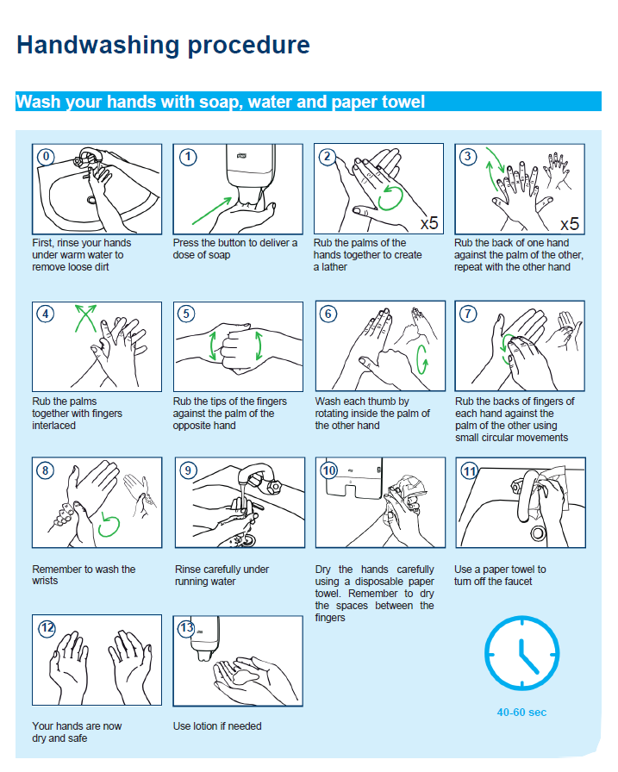

APPENDIX 2
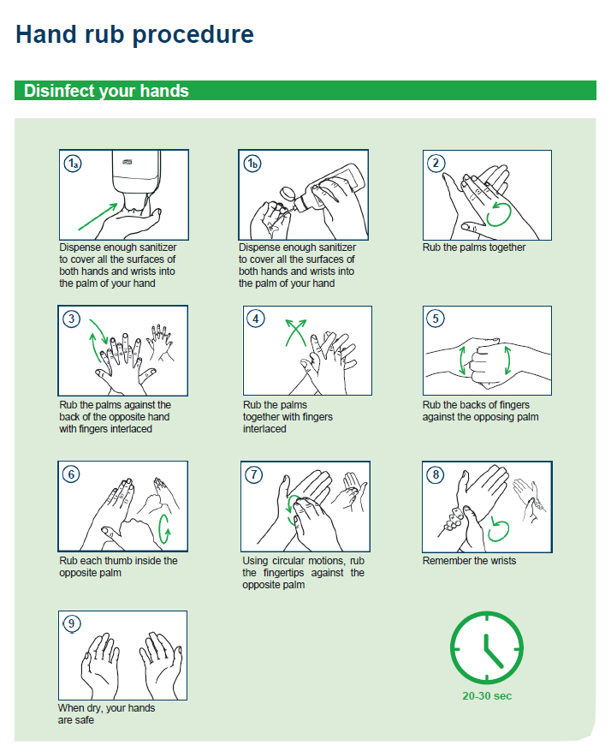

APPENDIX 3

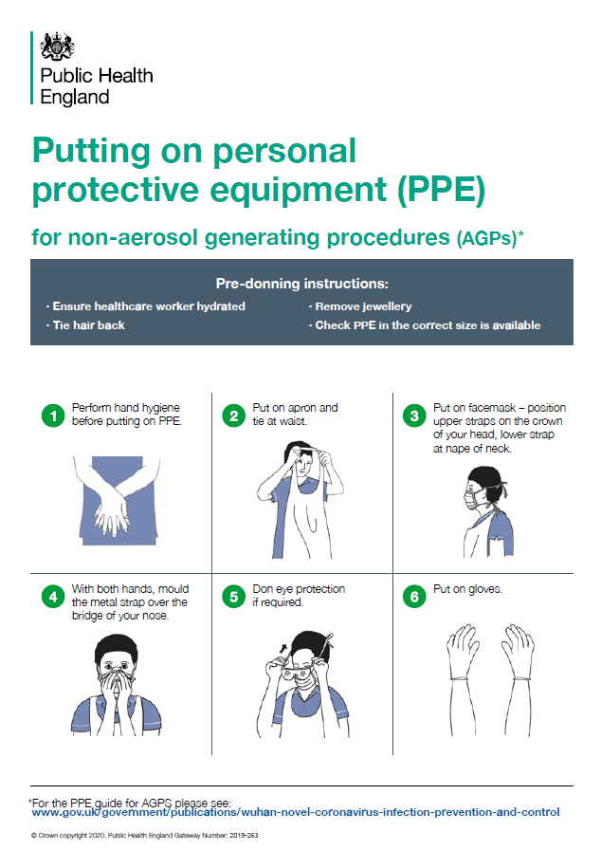

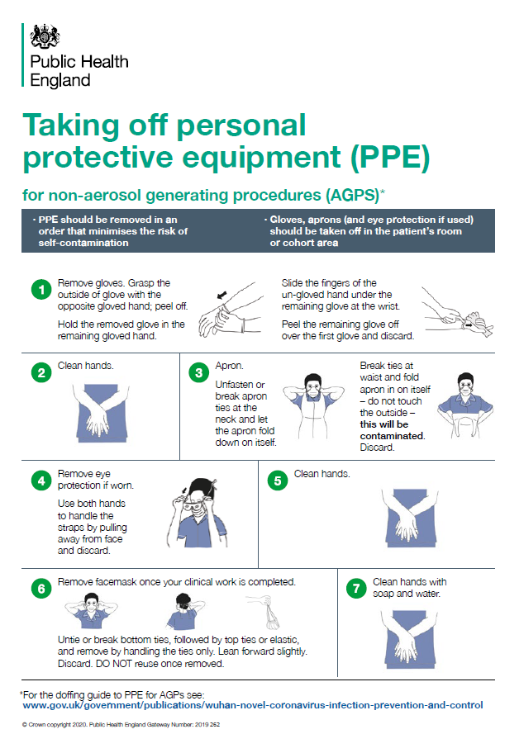

APPENDIX 6

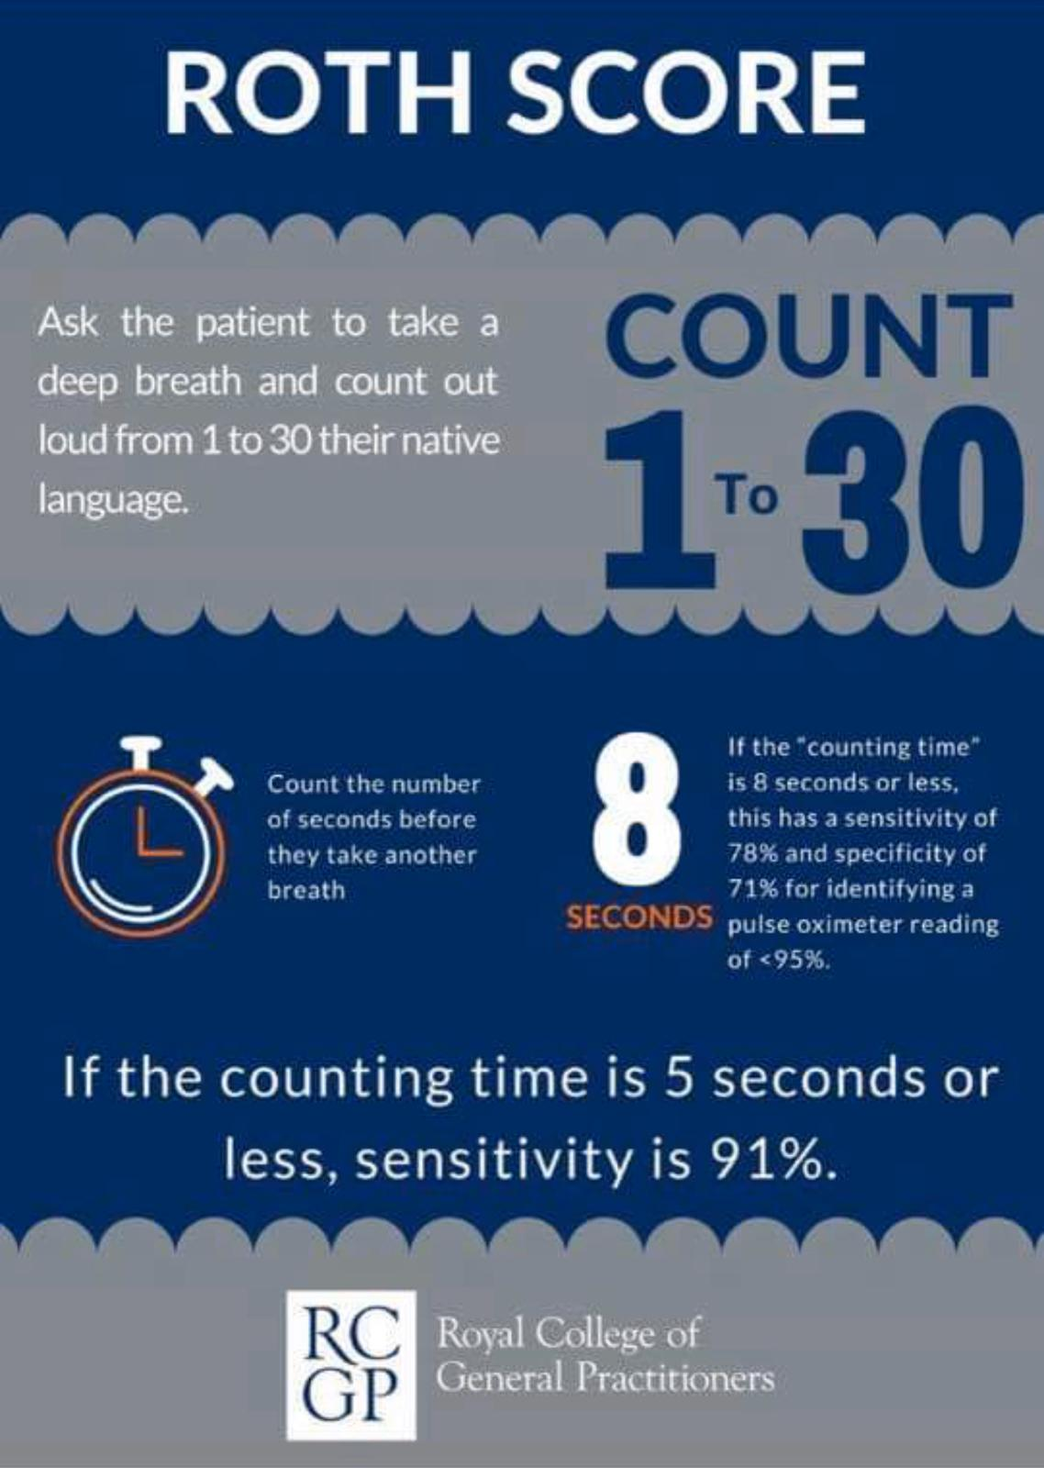

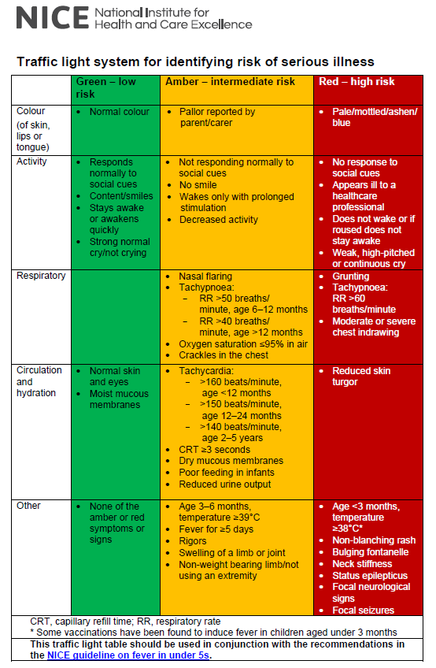
APPENDIX 7

CRB65+ score
APPENDIX 8

Calculating the score
Feature | Measure | Score
Confusion | Abbreviated mental test* score ≤ 8 | 1
Respiratory rate | >30/minute | 1
Blood pressure | Systolic < 90 mmHg or  Diastolic ≤ 60 mmHg | 1
65 | Or older | 1

*Age, recognition of two persons (e.g. doctor, nurse), DOB, address recall (e.g. 42 West Street), time, date of first or second world war, year, monarch, surgery name, count backwards 20 ➔ 1

Acting on the score
Score | Risk of mortality | Action
0 | Low | Manage with local antibiotic protocol
1,2 | Intermediate | Closely monitor response with low threshold for admission
3,4 | High | Call 999. Admit urgently and commence antibiotics before transfer. Risk of death increases with each hour.

VULNERABLE GROUPS
APPENDIX 9

Category A:  At Risk | Aged 70 or older (regardless of medical conditions)  Aged under 70 with an underlying health condition (i.e. anyone advised to get a flu jab as an adult each year on medical grounds | Social Distancing  Advised via official government advice
Category B:  At Very High Risk | - People with a solid organ transplant such as a kidney or liver transplant  - People with specific cancers:  -People with cancer who are undergoing active chemotherapy or radical radiotherapy for lung cancer  -People with cancers of the blood or bone marrow such as leukaemia, lymphoma or myeloma who are at any stage of treatment  -People having immunotherapy or other continuing antibody treatments for cancer  -People having other targeted cancer treatments which can affect the immune system, such as protein kinase inhibitors or PARP inhibitors.  -People who have had bone marrow or stem cell transplants in the last 6 months, or who are still taking immunosuppression drugs.  - People with severe respiratory conditions including all cystic fibrosis, severe asthma and severe COPD. See below.  - People with rare diseases and inborn errors of metabolism that significantly increase the risk of infections (such as SCID, homozygous sickle cell)  - People on immunosuppression therapies sufficient to significantly increase risk of infection  - People who are pregnant with significant congenital heart disease  - All patients on the following medications: Azathioprine, Mycophenolate (both types), cyclosporin, sirolimus, tacrolimus. | Shielding  Stay at home at all times and avoid any face-to-face contact for at least twelve weeks.  Contacted by NHSE
Category C:  At Very High Risk | - Patients with diabetes with HbA1c greater than 75, recent diabetic ketoacidosis or poor medication adherence;  - Patients with Chronic Obstructive Pulmonary Disease (COPD) who have required hospitalisation in the last 12 months or patients who have required 2 or more courses of steroids and/or antibiotics in the last 12 months;  - Patients with asthma with a history of hospitalisation in the last 12 months or ever been admitted to intensive care;  - Patients with significant heart failure which has required hospitalisation for their heart failure within the last 12 months;  - Patients with multiple long-term conditions;  - Patients who have had a splenectomy;  - Patients taking continuous oral corticosteroids of the equivalent of 20 mg of prednisolone or more for over 4 weeks;  - Patients taking immunosuppressive or immunomodulating medication such as ciclosporine, cyclophosphamide, azathioprine, leflunomide, methotrexate, mycophenolate. It is expected that patients taking these medications will be under a shared-care protocol with hospital specialist colleagues and a risk stratification approach should be taken. Advice can be sought from the relevant specialist.  - Guidance is available from the British Society of Rheumatology https://www.rheumatology.org.uk/news-policy/details/Covid19-Coronavirus-updatemembers  - Other patients that the general practitioner considers would be at high risk such as patients with severe dementia, cognitive impairment, frailty | Shielding  Stay at home at all times and avoid any face-to-face contact for at least twelve weeks  Advised via GP Practice

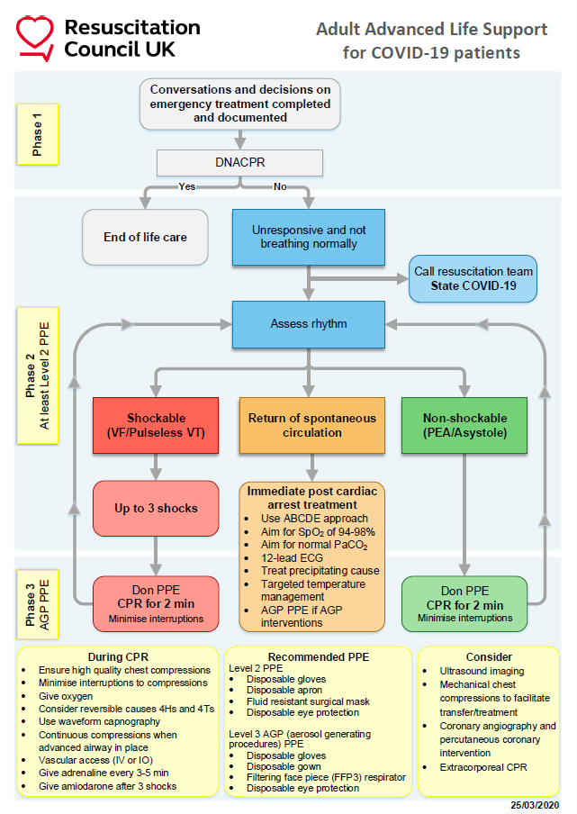
APPENDIX 10

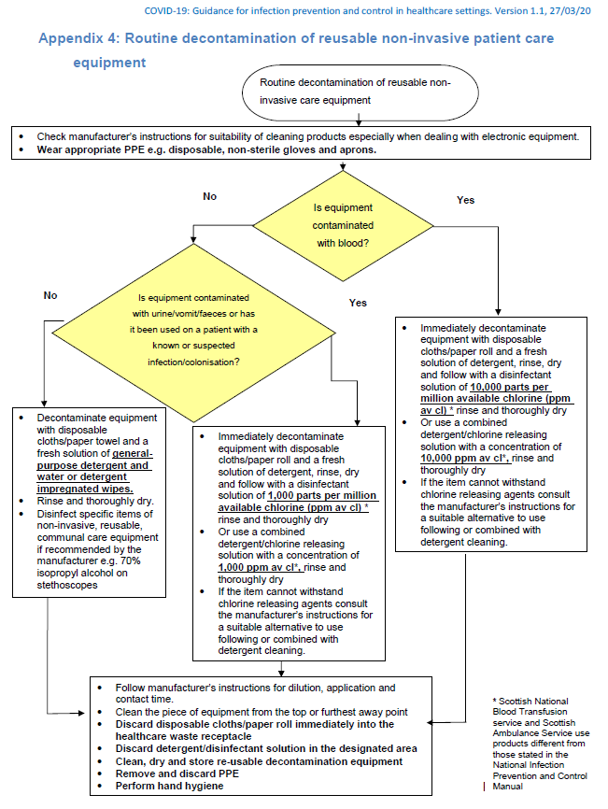
APPENDIX 11

APPENDIX 12

APPENDIX 13

HOT CLINIC STAFF ROTA (AS AT 30/03/2020)
APPENDIX 14

