Shakespeare Health Centre & Heathrow Medical Centre
COVID-19 Standard Operating Procedure
V5.0 24.03.2020

Table of Contents

About us 2
1. Background 3
2. About COVID-19 4
Symptoms 4
Incubation period 5
Mode of transmission 5
Differential Diagnosis 6
Prevention 6
3. Standard Operating Procedure 7
NHS Guidance and SOP on COVID-19 and general practice and Government advice 7
Additional measures adapted for our practice 8
4. Which Primary Care services should continue during the immediate pandemic? 9
5. Implementation steps for primary care 11
a. Priority 1: Ensure working environment is safe 11
Is the free flow of patients necessary in your practice? 11
Identifying an isolation room: 11
What if patients require to be seen at the practice? 11
b. Priority 2: Ensure staff safety 12
Practice personnel 12
Conducting risk assessment 12
Can selection of works cease? 12
c. Priority 3: Communication to staff and patients 13
Staff 13
Patients 13
Informing key stakeholders 13
d. Priority 4: Ensure patients receive high quality care 14
6. Appendix A - National guidance material from NHS E and PHE 17
7. Appendix B- Sample letter for patients prior to arrival to the practice 18
8. Appendix C- Information from specialist clinical departments 19
9. Appendix D- Technical support for electronic video and file transfer via AccuRx. 20
Video Consultation (via AccuRx) 20
How to send paperwork (e.g. blood forms & MED3) electronically 22
10. Appendix E- Frequently asked questions to reception team 25

About us

I hope this document helps you as much as it has helped us to transform our way of working. We have turned our practices upside down but have learned so much in the process! It is true that every disaster does present an opportunity as well. If you would like to share any learnings with me, I would be delighted to hear from you. I will continue to update this document as the chaos evolves but please don’t hesitate to contact me if you need help with anything and I will try my best to respond as soon as possible.
I have left this as a word document so please feel free to customise it to suit your own practice/PCN needs (just acknowledge us though 😉).

Good luck
Dr Jay Verma Mb ChB MRCS(Ed), MSc, RCGP
GP Partner at Shakespeare Health Centre
j.verma@nhs.net

Dr Sukin Natarajan B.Eng(Hon), PhD
Business Manager at Heathrow Medical Centre

Background

Coronaviruses come from a large family of viruses, coronaviridae, which can range from mild respiratory infections such as the common cold to more severe cases. It consists of an enveloped virus with a positive-sense single stranded RNA genome. There are currently seven known strains and some of the severe ones responsible for high number of mortality rates are: Middle East Respiratory Syndrome (MERS) and Severe Acute Respiratory Disease Syndrome (SARS). SARS-Cov2 (COVID-19 [coronavirus disease 2019]) is a recently discovered coronavirus that was responsible for the outbreak in the city of Wuhan in Hubei province in December 2019. On 11 March 2020, WHO declared COVID-19 a global pandemic.,, As of 22/03/2020, there are an estimated 294,110 confirmed cases of COVID-19 with about 12,944 deaths.
On 03 March 2020, the UK launched a plan consisting of four phases to tackle the outbreak: containment, delay, mitigation and research to work alongside the initial three phases. Containment measures were aimed at preventing the disease from taking hold and encompass early detection, isolation, and care of people already infected with careful tracing and screening of contacts. The delay phase aims to slow the spread and push the peak impact away from the winter season to reduce pressure on the NHS. Social distancing is part of such a strategy as is self-isolation. Finally, mitigation planning for widely established infection such as the use of supportive measures and medication will be introduced as we learn more about the virus.
So far Singapore has managed the outbreak well by doing the following:
- Rapid testing of suspected cases

- Communication: clear public health messages early on

- Individuals taking action to protect themselves

Since the first criteria is not within our control but the second and third are we should effectively communicate to our patients a systematic and consistent response that is in line with government guidance.
This operational plan has been written to provide guidance for general practices to manage their patients in the safest way possible. It aims to provide practices with a clear standardised approach to how best manage their patients whilst not compromising on essential care.

About COVID-19

Symptoms
The clinical symptom of COVID-19 ranges from asymptomatic or displaying few symptoms to patients requiring mechanical ventilation and supportive ITU care. As a result, some patients who may have respiratory failure might also go on to develop multi-organ dysfunction syndrome.
- Asymptomatic
- Mild symptoms of URTI
- Fever, cough, sore throat, nasal congestion, malaise, headache, muscle pain
- Moderate pneumonia
- Cough, SOB (tachyopnea in children)
- Severe pneumonia
- Fever, severe SOB, respiratory distress, tachyopnea (>30 breaths/min), and hypoxia (<90% on room air). Cyanosis may occur in childrens.
- Acute Respiratory Distress Syndrome (ARDS)
- Sepsis
- Death

Figure 1. Range of symptoms a patient with COVID-19 may exhibit.

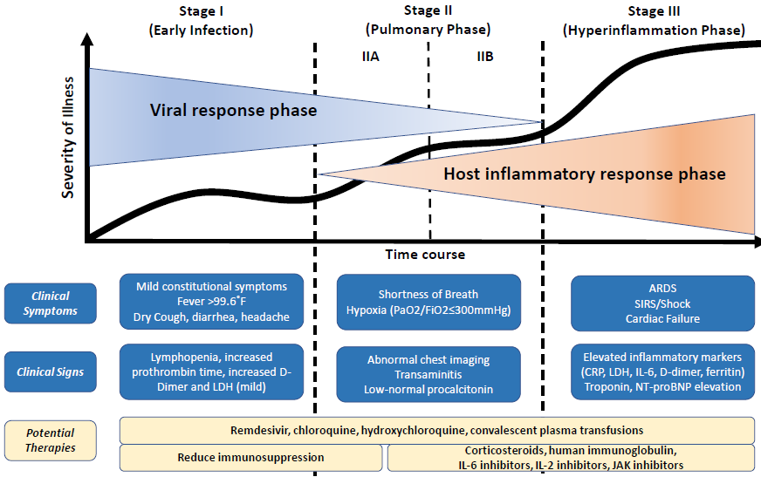

Figure 2. Severity and course duration of COVID-19

Incubation period
The incubation period is generally within 3 to 7 days and up to 2 weeks as the longest time from the infection to symptoms was 12.5 days (95% CI, 9.2 to 18).

Mode of transmission
The most common mode of transmission is believed to occur through respiratory droplets from coughing and sneezing. Aerosol transmission is also possible in case of protracted exposure to elevated aerosol concentrations in closed spaces. Close contact is also necessary for the virus to spread (see Figure 3).

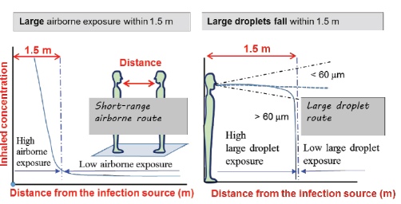

Figure 3. Comparison of exposure in short-range airborne route and large droplet route, showing highest concentrations of inhaled airborne and large droplet exposures within 1.5 meters.

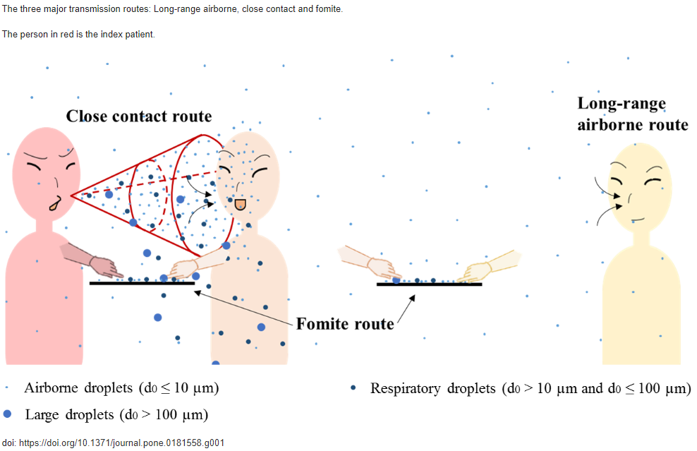
Figure 4. The role of fomites in SARS transmission during the largest hospital outbreak in Hong Kong.

Differential Diagnosis
Symptoms of the early stages of the disease are non-specific and the following have been linked with other organisms that may cause the common cold (e.g. Adenovirus, RSV etc.)

Prevention
The R₀ for COVID-19 is 2.2 (i.e. on average each patient transmits the infection to an additional 2.2 individuals) and therefore control measures must focus on reducing this to be less than 1. Preventative measures established by WHO and other organisations have issued the following guidance:
- Avoid close contact with subjects suffering from Acute respiratory infections
- Wash hands frequently, especially after contact with infected people or their environment.
- Avoid unprotected contact with farm or wild animals.
- People with URTI symptoms to keep distance and cover coughs or sneezes with disposable tissues or clothes and wash their hands.
- Strength the application of strict hygiene measures for the prevention and control of infections.
- Vulnerable and immunocompromised patients should avoid public gatherings.
It is recommended that healthcare workers caring for infected individuals should utilize contact.

Standard Operating Procedure

NHS Guidance and SOP on COVID-19 and general practice and Government advice
- Refer to Appendix A for the detailed guide
- Encourage patients with mild URTI symptoms to go into self-isolation.
- If symptoms worsen, then they must use the 111 online services first.
- If no internet, call 111 and for medical emergency dial 999.
- All patients that present to the practice/ring the practice for a clinical appointment should be asked:
  - Do you have a new, continuous cough?
  - Do you have a high temperature (37.8^{O}C or over)?
  - Does anyone in your household have a new, continuous cough or a high temperature?
If the answer is “yes” to any one of the above, ask:
Do you feel you can cope with your symptoms at home?
If they answer “no”, the patient should be immediately isolated in an isolation room away from other patients and staff and triaged remotely by a clinician in the practice.
- All patients should be remotely triaged to assess whether a face to face (F2F) appointment is clinically necessary.
- All currently pre-booked F2F appointments without prior triage need to be remotely triaged.
- Remote consultations should be used whenever possible.
- Infection Control Policy must be read before seeing patients and especially prior to doing home visits.
- If patients that do need to be seen in the practice, then an appropriate isolation room should be used.
- This isolation room can be the designated room for the remainder of the pandemic until such time dictated otherwise.
F2F review with a patient with suspected COVID-2
- All patients should be examined in an isolation room.
- The following PPE should be used in primary care is as follows:
  - Disposable plastic aprons
  - Disposable gloves
  - Fluid-resistant surgical mask (FRSM)
  - Eye protection

Additional measures adapted for our practice
- The rationale for the use of face masks in the COVID-19 pandemic has seen a wide range of variation across the countries. It is imperative to appreciate in the absence of evidence the UK recommends face masks play a vital important role in places such as hospitals. WHO advise the use of facemasks is needed for people taking care of a person suspected of COVID-19. The type of mask to be used appears to be somewhat of a contentious issue.

- Fluid-resistant (Type IIR) surgical mask (FRSM) is a loose-fitting, disposable device that creates a physical barrier between the mouth and nose of the wearer and potential contaminants in the surrounding environment. The edges of the mask are not designed to form a seal around the nose and mouth.

- Overall observational evidence suggests the use of respirators such as FFP2 (equivalent version is N95) and FRSM offer the same level of protection with up to 80% reduction in risk of SARS albeit the effectiveness against pH1N1 was found to be unclear.

- Our approach in the absence of sound evidence, we have decided to use the following additional measures:
  - Wearing FRSM or FFP2/FFP3 does not replace good hygiene measures such as washing hands; how to appropriately don on and take off PPE; and risk assessing every situation.
  - The PPE provided by NHS England should be adequate to provide protection from respiratory droplets, but it is important to bear in mind that patients with URTI should also be wearing PPE in order to prevent any accidental spread of respiratory droplets.
  - For additional protection, practices may wish to purchase the following:
    - Surgical scrubs
      - Ensure these are washed daily in high heat
    - Protective face shield
      - Patients seldom warn you if they are about to cough/sneeze and therefore it may be sensible to wear a visor to ensure the patient’s involuntary action does not put you at risk
    - Warrior type 5/6 Hooded Hazmat Suits
      - This will ensure that fomite transmission is to a minimum as this will be changed per shift. Do not take this home!
    - Shoe covers
      - This is more for home visits and again protects against fomite transmission route.

Which Primary Care services should continue during the immediate pandemic?

Table 1. A guide to some of the different services that are on offer in primary care
 | Type of service | Continue?  (Y/N) | Alternative to usual method if to continue
GP | BP checks (unstable) | Y | RW- telephone with BP done at home/pharmacy etc.
 | Blood results | Y | N/A
 | Clinical queries from patients: Acute | Y | RW- telephone/video
 | Clinical queries from patients: Routine | N
 | Enhanced Services: QOF | N
 | Enhanced Services: LES/LIS | N
 | Enhanced Services: PCN activity | N
 | LTC reviews: Acute | Y | RW- telephone/video
 | Home visits: Acute | Y | RW- telephone/video
 | Home visits: Routine | N
 | Routine: Baby checks | Y | PPE to be used
 | Minor joint injections/surgery | N
 | Additional Services for PCNs | N
 | Additional Services for Confederation | N
Nurse | ABPI | N
 | Baby/child immunisations | Y | PPE to be used (further info email: england.londonimms@nhs.net)
 | BP checks (routine) | N
 | Cervical smears | N
 | Depot injections | Y | PPE to be used (alternative- consider referral to CMH to give at home)
 | Diabetic foot checks | N
 | Depo-Provera | N | See Appendix C (alternative- start POP)
 | Ear syringing | N
 | LTC reviews: Routine | Y | RW- telephone/video review only
 | Flu immunisations | - | Assess clinical need
 | Routine: BP checks | N
 | Routine: immunisations  (e.g. Pneumococcal, Shingles, Men ACWY) | - | Assess clinical need
 | Whooping cough | Y | PPE to be used
 | Wound check/review | Y | 1st: RW- video; 2nd instance: F2F and PPE?
 | Wound dressing | Y | PPE to be used
 | Vitamin B12 injection | N | Cyanocobalamin tablets?
Pharmacist | Medication reviews | Y | RW- telephone
 | Prescriptions (acute/repeats) | Y | RW- telephone
 | High Risk Drug Monitoring | Y | RW- telephone

Table 1 continued
Teaching | Teaching: 5th Year Kings Medical Students | - | Revise in October 2020
 | Teaching: Nursing Students | N
 | Teaching: GPVTS | N/A
Admin | New registrations | Y | Remotely with no new health checks
 | Routine referrals | N
 | Sample drop-offs (e.g. urine) | - | Clinical decision and should be scheduled
 | Urgent referrals (2WW, RACPC, TIA/Stroke etc.) | Y | N/A

Key:
RW: Remote Working
PPE: Personal Protective Equipment (surgical mask/FFP2/FFP3; face shield; Hazmat suit; apron; gloves; shoe covers [if doing Home visits])

Implementation steps for primary care

Priority 1: Ensure working environment is safe

Is the free flow of patients necessary in your practice?
This is important to establish as each person walking through the door is a potential carrier of COVID-19. Some practices have resorted to asking screening questions before patients attend the practice but bear in mind a significant majority of patients may not display any symptoms or signs. Furthermore, screen protection may prevent air droplet transmission but since COVID-19 can be transmitted by fomite route, practices need to restrict and control the flow of patients to the absolute essential.

Identifying an isolation room:
The practice will identify an isolation room that has the minimum footprint internally and is the closest to entry/exit.
Aim: The patient must spend the least amount of time with the clinician as possible (ideally aim for <5mins).

- Ensure the isolation room is prepared as shown below.
- Prior to the patient attending a patient information leaflet can be sent to the patient to read and explain the process. This can also be verbally done by the reception team.
- Patient attends door and informs reception by telephone that they have arrived.
- The clinician (wearing PPE) will greet the patient at the door and advise which room to go to.
- The patient must wash hands and if appropriate don on PPE (prevent fomite transmission).
- The patient is advised to check temperature, BP, HR, and saturation probe. The readings are recorded on a sheet or pictures can be taken of the readings.
- Following which the patient will then sit down await the clinician. It may be reasonable to ask the patient to expose the area that requires examination prior to the clinician attending.
- The clinician must wash hands and done on new PPE.
- The clinician will examine the patient and provided there are no immediate medical concerns exit the room.

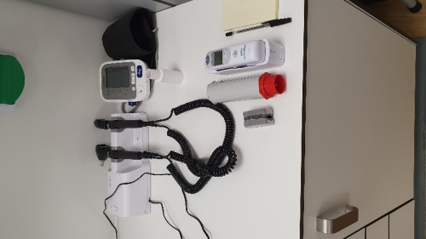
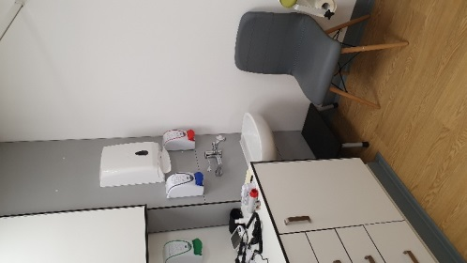
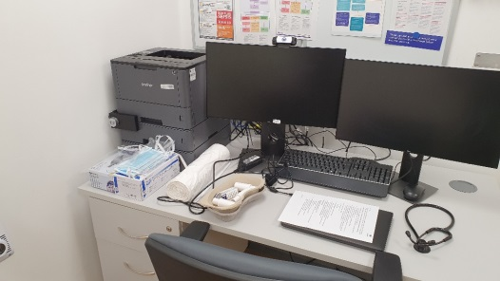
What if patients require to be seen at the practice?
- Clinician sits at least 2 metres away from the patient and wears PPE
- Patient instructed to check temperature, BP, and pulse oxygen saturation
- Patient is instructed to wash hands on arrival
- Don on PPE (esp. surgical face mask)
- Has the Infection Control Policy been reviewed beforehand, and suggested measures implemented?
- Has an isolation room been identified?
- Do you have the available PPE in place?
- Is there dedicated equipment just for use in the isolation room present?
- Will you ask the patient to wear PPE as well? Remember the risk is bidirectional and both individuals must protect themselves from each other. Naturally this may not be possible in some individuals such as frail patients or in young children/babies. A risk assessment will need to be done for each individual contact.
- How will you ensure the minimal time is spent with the patient? Our tip is a thorough history taking prior to arrival and ask patient to self-assess vitals either at home or in the isolation room, prior to the clinician examining the patient.

Priority 2: Ensure staff safety

Practice personnel
Under the Management of Health and Safety at Work Regulations 1999, the minimum an employer must do is:
- identify what could cause injury or illness in your business (hazards)
- decide how likely it is that someone could be harmed and how seriously (the risk)
- take action to eliminate the hazard, or if this isn’t possible, control the risk

Conducting risk assessment
All staff require a clinical risk assessment to be undertaken immediately (you can create this in Google Forms or on SurveyMonkey and then attribute risk scoring to it in Excel).
- For those individuals that require self-isolating at home, can they work from home with remote access?

Can selection of works cease?
- Only see patients at your practice if absolutely necessary (Table 1)
- Suspect everyone as a potential risk of having COVID-19 (may be asymptomatic carriers of the virus) and thus ensure you keep at least at least 2 meters apart in the work environment (Figure 3).

Priority 3: Communication to staff and patients

Staff
- Is everyone aware of their roles based on any new changes made or added to their job descriptions?
- Are your administrative staffs clear on what to say to patients based on questions asked by patients? (see Appendix E)

Patients
- Inform online booking has been disabled.
- All clinical queries will be triaged either over the phone or by video.
- Are posters displayed outside your door explaining not to enter the premises but to ring ahead first?
- Have text messages been sent out to all patients? Perhaps weekly text messages to update patients; or as needed when significant changes occur in the practice may be helpful to keep patients informed.
- Is your website updated with the relevant information? Perhaps attach important links to it so patients may self-direct.
- If a patient is being seen at the practice, do you have a template letter to send? (Appendix B)

Informing key stakeholders
- Daily situational updates to PCNs, CCG & Federation will be needed if your Business Continuity Plan is in jeopardy.
- Weekly updates to be sent to the PCN, CCG & Federation.
- Regular meeting with PPG virtually will help to spread the measure for patients to self-isolate

Priority 4: Ensure patients receive high quality care

- All patients are to be triaged by reception team initially and the three questions listed above need to be asked.
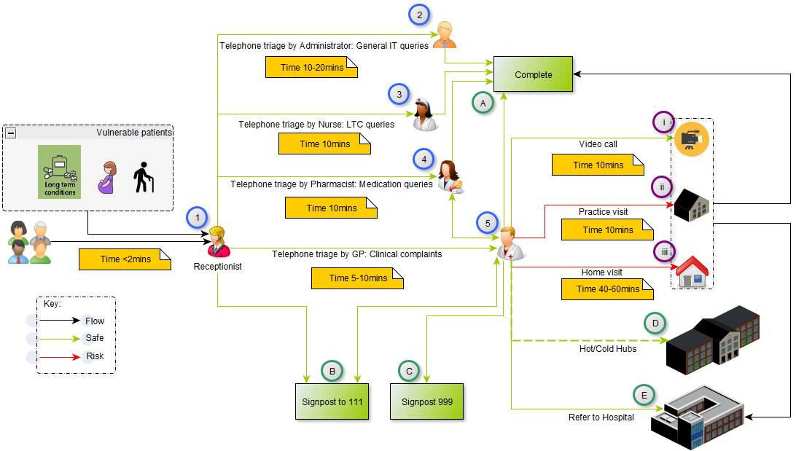

Figure 5. An operational flow map to ensure safe streaming of patients

- Vulnerable patients have an EMIS safety alert added (1) to their records to ensure their calls are prioritised
- All calls need to be closed within 2 minutes by reception team. Greeting may be in the format:

  - Hello, thank you for phoning [PRACTICE NAME]. My name is [NAME], how may I assist you with your call today? (see Appendix E for FAQs)

  - Since all calls are triaged… you can mention that someone will ring you back a [specified time period, e.g. 4 hours].

- They will be handed over to (see Figure 5):
  - A trained Administrator (2) to deal with general administrative or IT queries (Appendix D)
  - Nurse (3) to discuss recent results from blood tests (e.g. glucose/HbA1c or lipids), review LTCs or other relevant queries
  - Pharmacist (4) to deal with medications queries or conduct reviews
  - GP (5) to deal with clinical complaints over the telephone or alternatively decide whether the call should be managed by 111/999 (B/C); refer to the Hot/Cold Hubs (D [currently not set up]); secondary care (E); or conduct another mode of consultation type(i-iii).
- GPs will primarily deal with pressing acute complaints and any routine queries will be managed at the same time if time permits and is not too onerous on the clinician.
- Some crude quick tips that can be used during telephone/video triage (this is not all evidence based!)
  - I always try to build a mental picture in my head whilst triaging. It often helps.
  - Ask patient to assess heart rate with Fitbit or any other device (e.g. Smart Phone).
  - If the patient is conversing well and alert, it may be reasonable to assume that he or she has reasonable cerebral perfusion and therefore using ATLS principles, the systolic blood pressure of his or her carotid artery is likely to be between 70-80mm Hg. Furthermore, if the patient is able to squat and stand up easily without feeling dizzy/lightheaded (within 3 minutes) then he/she is likely to not have a systolic difference of at least 20mm Hg and 10mm Hg diastolic .
  - Assess patient’s breathing status by asking patient to take a deep breath and count from 1 to 30. The Roth score can help with identifying patients at risk of having higher-severity dyspnoea as the maximal counting number <10 or counting time <7 seconds identified patients with room-air pulse oximetry <95% with sensitivity of 91% and 83% respectively. Maximal counting number <7 or counting time <5 seconds identified patients with a room-air pulse oximetry <90% with sensitivity of 87% and 82% respectively. Please bear in mind this can be influenced by demographics including the patient’s profession!
  - Asking a patient to measure his/her urine output over 24hrs could be helpful to decide if he or she is urinating normally as an average adult should urinate between 0.5-1ml/kg/hr and patients over 65 would be 50% less.
  - During video calls, it may possible to comment on the following:
    - Demeanour
    - Mobility status
    - Abdominal history- ask patient to point! (is it foregut/midgut or hindgut pain?)
    - Tonsils
    - Colour of skin, eyes, tongue and lips (cyanosis)
    - Respiratory rate
    - Capillary refill time (check central sternum area)
    - Rash
    - Can he or she jump up and down okay (patients with peritonitis seldom can); hop test?!
    - Use of accessory muscles (head bobbing in infants); chest wall movement; sternal, supra-clavicular, sub-sternal or intercostal recession.
- The GP will need to decide on how to complete the call and if not possible, will decide to augment his/her clinical analysis by seeing the patient F2F or referring the patient to a Hub.
- If a patient is brought to the practice or a home visit is conducted, then please note there is a risk of infection as we must assume ALL patients (irrelevant if they have symptoms or not) have the suspected COVID-19 until proven otherwise!
- If the patient is seen, then the consultation should take no more than 5 minutes as most of the history taking would be taken prior to arrival. The aim is to spend the least amount of time with the patient possible in order to assess whether safe to go home or not.
- The clinician dons off the PPE as illustrated in Appendix A.
- The patient is shown how to dispose of the PPE (Appendix A) and asked to wash his/her hands to remove any potential contaminants obtained through fomites.
- The patient is then managed by either being referred to secondary care (C) or the consultation is completed (D).

Appendix A - National guidance material from NHS E and PHE

- NHS Guidance and standard operating procedures: Coronavirus and general practice

- Infection Prevention and Control guidance

- Surgical face mask or FFP3 respirator

- Putting on PPE

- Taking off PPE

Appendix B- Sample letter for patients prior to arrival to the practice

Dear Patient,
You have been booked into the [practice/hub name] for patients who do not have symptoms of possible COVID-19 but have other viral or respiratory symptoms that require a physical assessment.
To protect you, our patients and our staff please read the following instructions carefully:
- Make your way to the [designated area].
- Use the sink on entering the room and wash your hands thoroughly with soap and water for at least 20 seconds (see poster on wall).
- Wear the PPE as shown.
- Take a seat and wait for the arrival of the clinician.
- Please avoid moving around in the room and touching items or furniture.
- Please ensure your mobile is switched on.
- Use the ear thermometer in front of you to check your temperature (once in each ear) and note down the higher reading on the piece of paper in front of you.
- Put the oxygen probe in front of you on one of your fingers and after 30 seconds note down the top (pulse) and bottom (oxygen saturation) reading on the piece of paper in front of you.
- If you feel seriously unwell at any stage please alert a member of staff !
The criteria for possible COVID 19 are:
- A new continuous cough
OR
- A fever over 37.8
If you have developed any of those symptoms you need to:
- Return home by the most direct route and avoid public transport
- Stay away from other people for at least the next 7 days or longer if your symptoms continue.
- Testing for coronavirus is not needed if you're staying at home.
- Contact 111 if you feel you can’t cope with your symptoms or your condition gets worse.
- Stay at least 2 meters (about 3 steps) away from people if you can.
- To protect others, do not go to a GP, pharmacy or hospital!
The assessment consists of:
- A five to ten minute remote assessment (via phone/video)
Following this assessment the clinician may:
  - Advise you that you need to return home and give you instructions on how to manage your symptoms
  - Prescribe medication
  - Refer you to the hospital if they feel you are unwell
- A focused physical examination (if absolutely necessary)
  - The clinician will enter the room wearing protective equipment
  - Maintain a safe distance of 2 meters (if possible)
  - Carry out a focused examination as necessary
  - Discuss and agree a management plan with you (this may be by phone)

Appendix C- Information from specialist clinical departments

- The Faculty of Sexual & Reproductive Healthcare of the Royal College of Obstetricians & Gynaecologists

Appendix D- Technical support for electronic video and file transfer via AccuRx.

Video Consultation (via AccuRx)
Ensure AccuRx is installed and configured for the user. It should look like below (if it does not see install and setup guide separately)

How does AccuRx Video work?
AccuRx sends a unique link to the patient’s mobile number (and one to the GP number/PC). It can operate on any PC with a webcam (preferred) or any GP smartphone (without sharing the GP phone number).

How to start a video session?
Load the patient in EMIS  Click on the video image on Accurx  Ensure the patients mobile number is displayed at the top  Consent the patient and explain the process  - I will send you a text message  - Click on the link  - No need to install any app  - Give permission  - Join meeting  If you have webcam enter  n/a in the your mobile number box or  enter your actual mobile number in this box  Click Send and save  A text message will be sent to the patient (and your mobile if you have provided it)  It is best to stay on the phone until the patient completes their steps. | 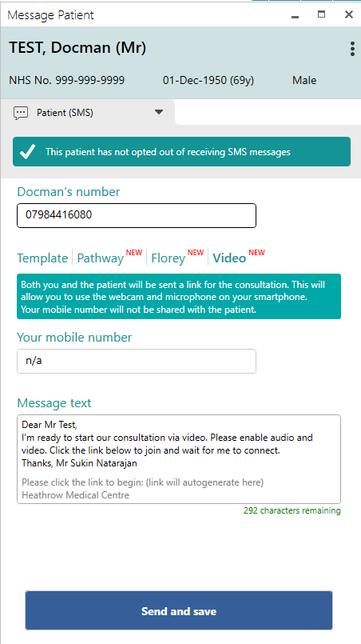
AccuRx displays a copy of the message it has just sent to the patient.  If you have webcam  Click this link on your PC/laptop  If you only have a mobile  Click the link on your phone text message | 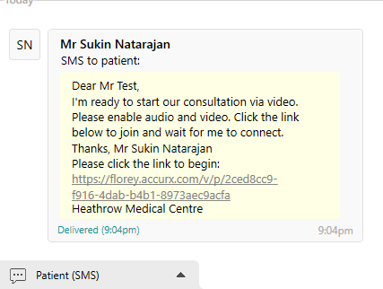
ONLY WORKS WITH GOOGLE CHROME  If you see the message opposite it means internet explorer is set as your default browser  Open Google Chrome (on your desktop)  Right click on the unique link above and select copy shortcut  Paste in to address bar into google chrome  You may wish to set google chrome as a default browser but this may not work for eRS referrals.  https://www.laptopmag.com/articles/make-chrome-firefox-default-browser-windows-10 | 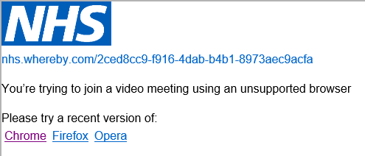  Alternatively you can  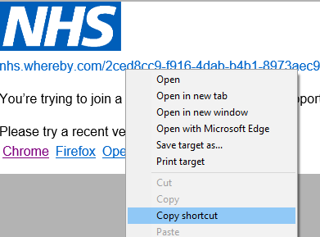
Click Continue or Join Meeting  You will then be able to see yourself (if you have webcam/phone) and the patient when they also join the meeting. | 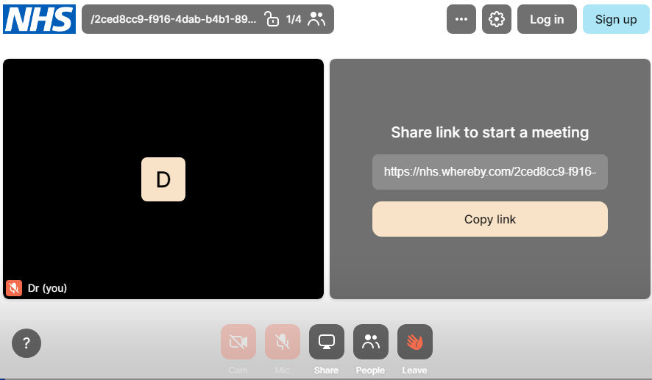
Other troubleshooting | Solution
Patient cannot enable camera/microphone | - Try another mobile number (family member)  OR  - Send them accurx template on video consultation – enabling camera and microphone and try again after some time  https://support.accurx.com/en/articles/3779266-video-consultation-problems-enabling-camera-or-microphone
For further help | Access the help feature from the AccuRx main menu  Left click on your initials and select help and search for video:  https://support.accurx.com/en/?q=video  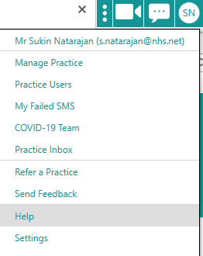

How to send paperwork (e.g. blood forms & MED3) electronically
Obtain consent that the patient is happy to receive this by text link (preferred) or email.

Part 1: Print to PDF (or scan to PDF)
All CCG Windows 10 PCs have a virtual printer called “Microsoft Print to PDF”. You can print use this printer to print virtually anything to a PDF. When asked to select printer – choose “Microsoft print to PDF” (or equivalent if you have alternative installed), see below.
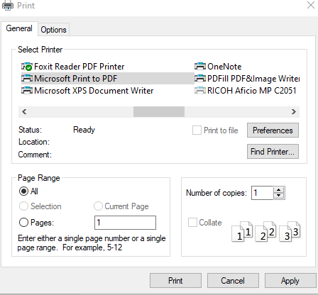

Provide a suitable initial and save to the desktop. Alternatively scan any paper document to a PDF and save to desktop (methods vary) save to the desktop.

TIP: MED3 notes could be
- Signed electronically (if facilities exists) or
- Noted in the comment text as “not signed manually due to covid19” or
- Printed and signed and scanned to a PDF and then attached to text message via AccuRx

Part 2: Send via AccuRx

Select the patient on EMIS as usual  Click the text icon as usual  Type a suitable message and  Click “Attach file”  Select the PDF file you wish to send (click ok)  Select Send and Save | 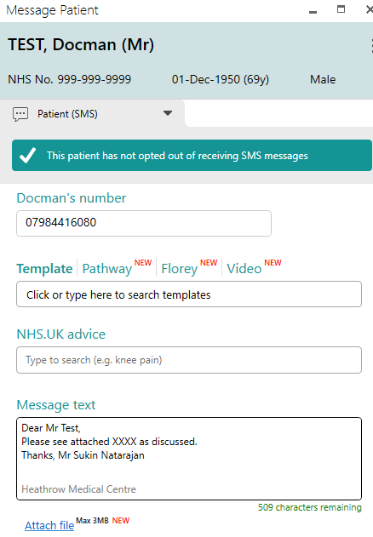

- The patient will receive a text message with a secure link to download the file.
- They will need to enter their date of birth to download the file.
- They can easily view the file on their phone or forward the link to any email or person if they need to print it.
- It is possible to electronically sign PDFs although this process is covered at this time.

Appendix E- Frequently asked questions to reception team

- “I have underlying health issues, e.g. asthma or diabetes; therefore I need a doctor’s letter to show it to my employers.”

Our approach: Ask patient to either use Patient Online (view summary) or we are providing a brief summary electronically. Furthermore, letters will be sent to them in due course.

- “I need a letter in writing from the GP explaining my underlying health issue and to inform my employers that I should quarantine myself for 12 weeks.”

Our approach: A letter will be sent out to all patients that are at risk in due course.

- “I have been coughing for the last few days, difficult to breath, slight temperature but not sure if it is related to my asthma.”

Our approach: Triage to duty doctor for remote telephone/video (based on patient preference) consultation

- “I am struggling to breath, and coughing, with slight temp not asthmatic but I have allergies, shall I self-isolate also?”

Our approach: Triage to duty doctor for remote telephone/video (based on patient preference) consultation

- “I have had temp for over a week but my symptoms have not improved, do I need to continue to isolate or shall I call 111?”

Our approach: If patient well with ADLS, advised to complete the 111 online questionnaires

- “If I have flu-like/COVID-19 symptoms, then what medication shall I take?”

Our approach: visit NHS Choices but if well (can do all ADLs) self-isolate and take simple home remedies. If symptoms deteriorate, patient must either ring 111 or the practice.

- “Can you please prescribe paracetamol as there is a shortage and am self-isolating due to my health issues and age?”

Our approach: Discretionary based on clinical context but we are advising the majority of our patients to try alternative retailers.

- “Is it true if you take ibuprofen than your flu symptoms will get worst?”

Our approach: Currently no evidence to suggest this! (https://www.gov.uk/government/news/ibuprofen-use-and-covid19coronavirus)

- Patients requesting medication more than is needed in advance
Our approach: AccuRx message template ready and send out to patient, whilst rejecting request.
- Patients are also calling for simple, minor ailments such as symptoms suggestive of conjunctivitis

Our approach: Signpost to NHS Choices

https://www.who.int/news-room/q-a-detail/q-a-coronaviruses
https://emedicine.medscape.com/article/2500114-overview
https://www.gov.uk/government/publications/coronavirus-action-plan/coronavirus-action-plan-a-guide-to-what-you-can-expect-across-the-uk
https://experience.arcgis.com/experience/685d0ace521648f8a5beeeee1b9125cd
https://doi.org/10.1016/S2213-2600(20)30128-4
https://www.ncbi.nlm.nih.gov/books/NBK554776/ (Features, Evaluation and Treatment Coronavirus (COVID-19) StatPearls [Internet]
https://els-jbs-prod-cdn.literatumonline.com/pb/assets/raw/Health%20Advance/journals/healun/Article_2-1584647583070.pdf
Urbanization and slums: Infectious Diseases in the build environment: proceedings of a workshop (2018) https://www.nap.edu/read/25070/chapter/4#25
https://journals.plos.org/plosone/article/figure?id=10.1371/journal.pone.0181558.g001
https://www.england.nhs.uk/coronavirus/wp-content/uploads/sites/52/2020/03/Managing-coronavirus-COVID-19-in-general-practice-GP-SOP_19-March.pdf
https://www.gov.uk/government/news/covid-19-government-announces-moving-out-of-contain-phase-and-into-delay
https://111.nhs.uk/covid-19
https://www.thelancet.com/journals/lanres/article/PIIS2213-2600(20)30134-X/fulltext
https://www.fda.gov/medical-devices/personal-protective-equipment-infection-control/n95-respirators-and-surgical-masks-face-masks
Offeddu V, Yung CF, Low MSF, et al. Effectiveness of Masks and Respirators Against Respiratory Infections in Healthcare Workers: A Systematic Review and Meta-Analysis. Clin Infect Dis 2017; 65: 1934-1942. 2017/11/16. DOI: 10.1093/cid/cix681.
https://www.hse.gov.uk/simple-health-safety/risk/index.htm
https://docs.google.com/forms/d/e/1FAIpQLSdj30Jo3etse4uYhExTK8EJm__0mve2IQyvBmJHJrDyDAp4KQ/viewform?vc=0&c=0&w=1&fbzx=7093625737190585748
https://www.bmj.com/content/342/bmj.d3128
https://www.ncbi.nlm.nih.gov/pmc/articles/PMC6490799/pdf/CLC-39-636.pdf
http://www.columbia.edu/itc/hs/medical/humandev/2004/Chapt18-Endoderm.pdf
https://emj.bmj.com/content/29/5/422.2
https://emj.bmj.com/content/21/4/511

